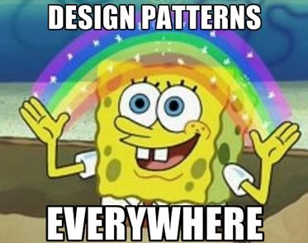

# Game Programming Patterns

# http://gameprogrammingpatterns.com/contents.html

# Modeling

## Class diagram

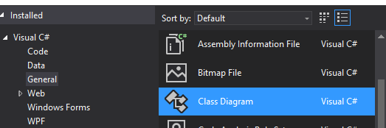

Is actually way to represent your C# program in Class Digram

## UML

Unified Model Language

OMG.org

### Types

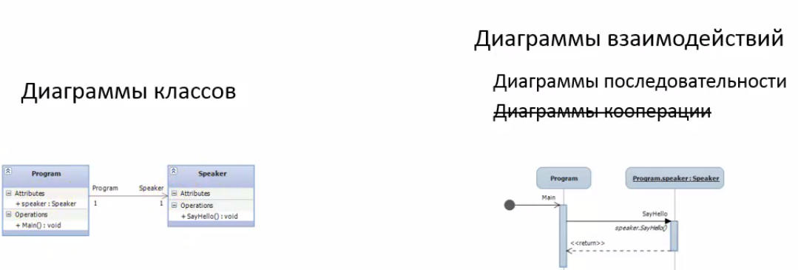

### Syntaxes

+ Public

- Private

# Protected

~ Package (default visibility)

Other properties of class members, we can indicate with the format of the text:

underline static

italic abstract

all-caps constants

### Dependency types

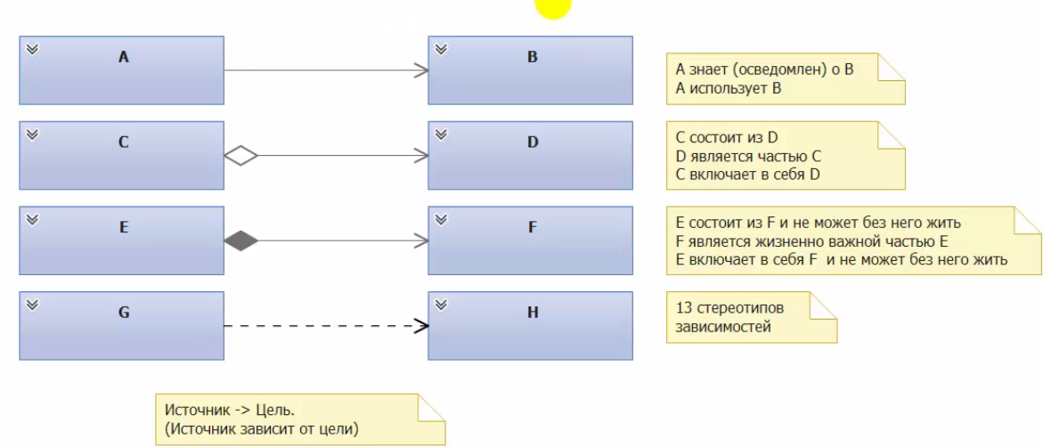

13 Стереотипов зависимости:

1. Create (Рание связивание)
2. Import
3. Instantiate (Позние Связывание)

## Visual Studio Tools

### Code Map

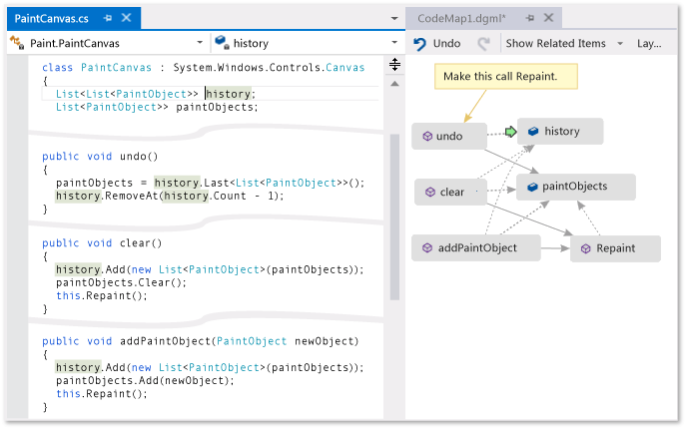

#### Basic activation

Seeing what we reference and what reference us.

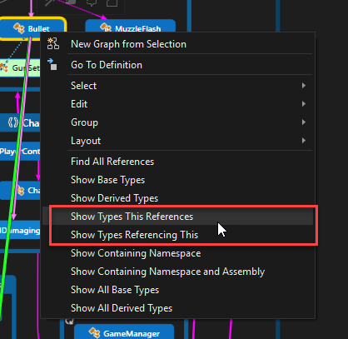

#### Circular reference

BINGO! All I really need from code map.

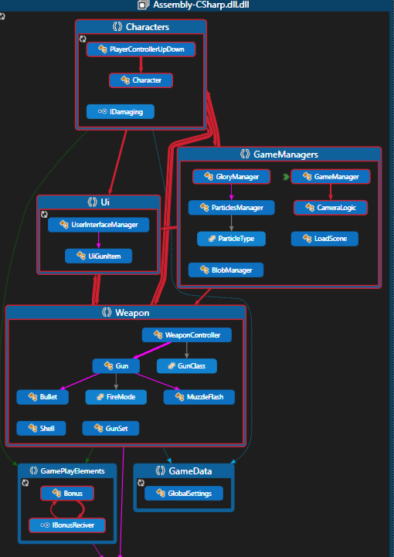

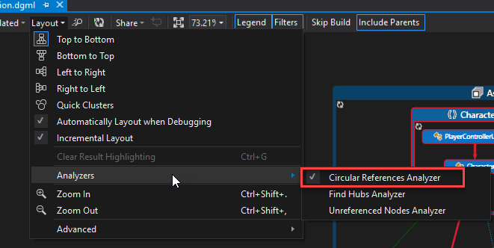

### Visio

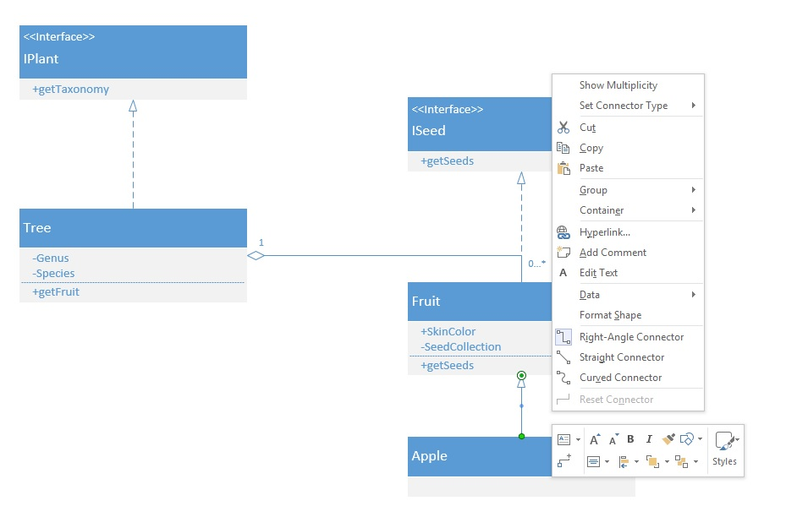

### Code clone detection

<https://msdn.microsoft.com/en-us/library/hh205279.aspx?f=255&MSPPError=-2147217396>

### Class diagram

Creates diagram of existing code.

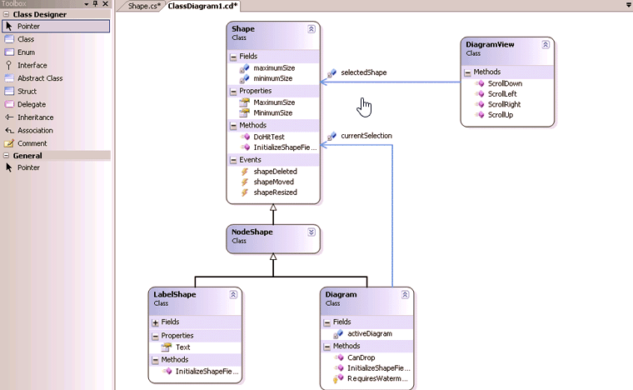

# Design Patterns Theory

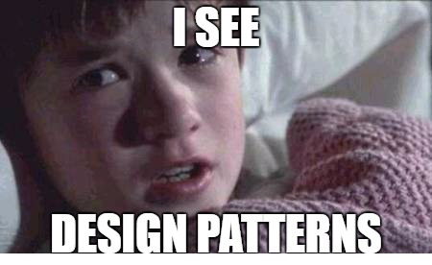

## Paradigms of OOP

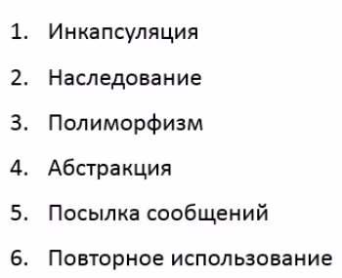

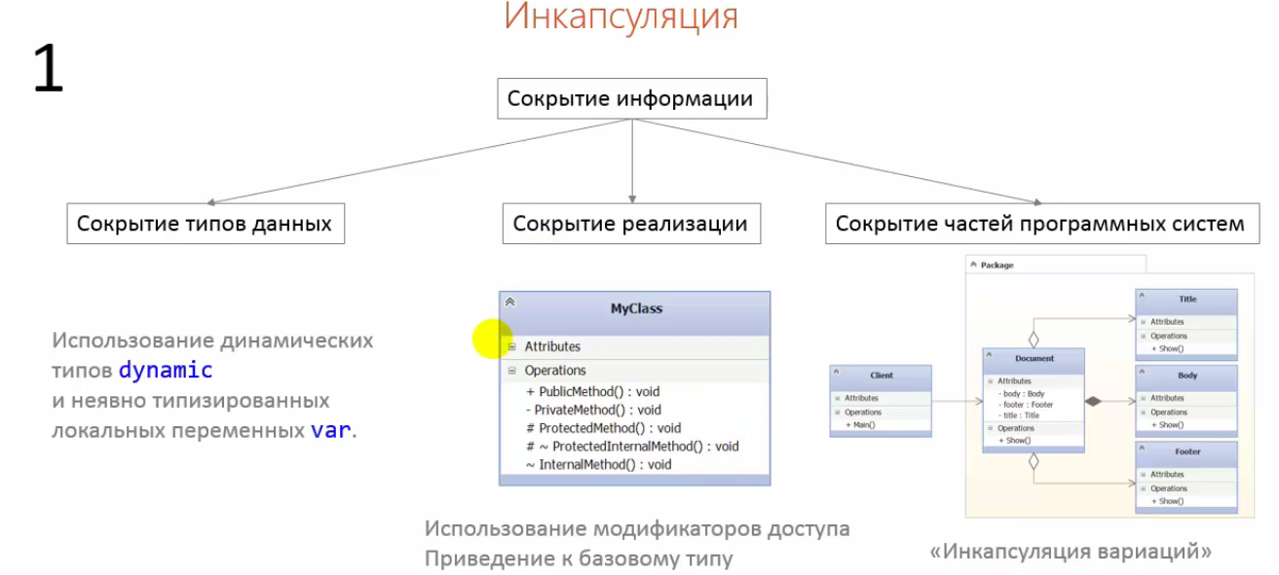

## SOLID

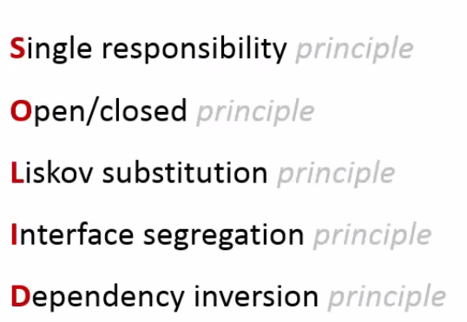

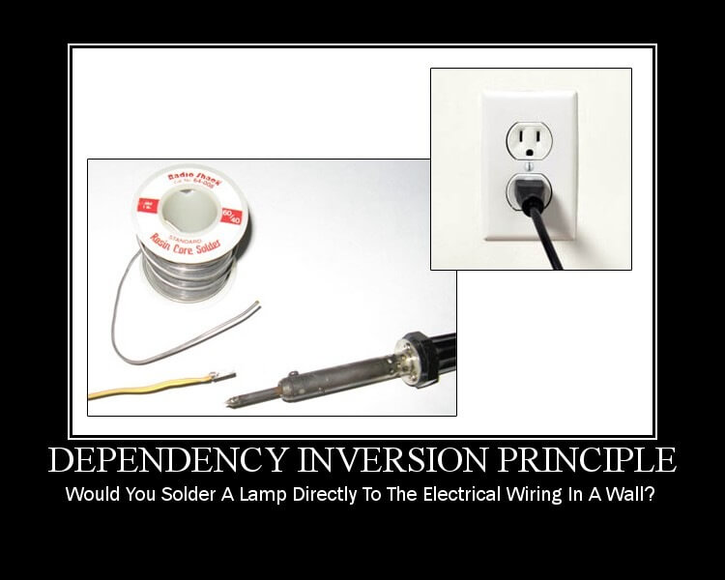



Single responsibility – Just one functionality in one class.

Open/Closed – Your class is open to extrude. In addition, Close for modification.

Liskov subtraction- Use inherence only if inherence class is more specialized version of base class.

Interface segregation – Short and Long Interface.

Dependency inversion – инверсии зависемости.

## Techniques

2 type of techniques

1. Creating
2. Structure
3. Behaviour

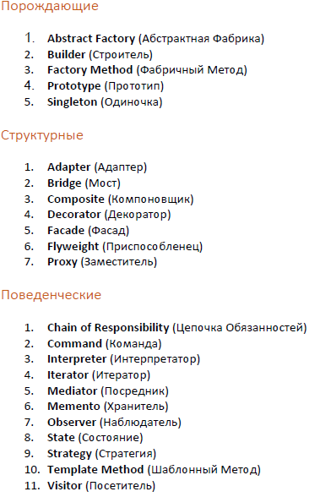

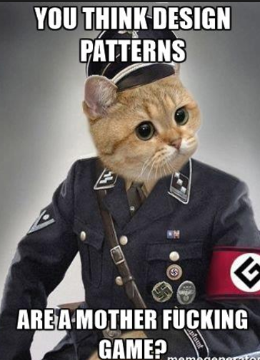

Rules OOP – Creating

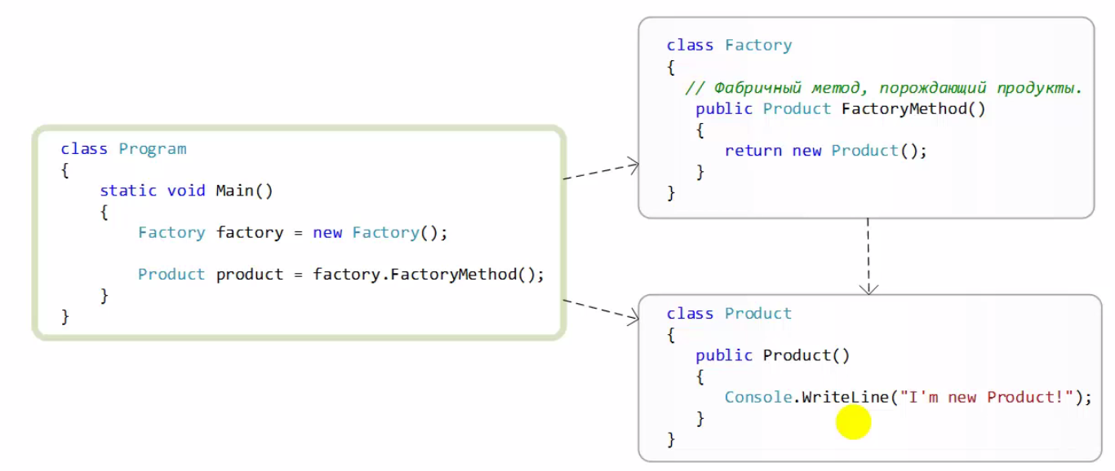

### Structural

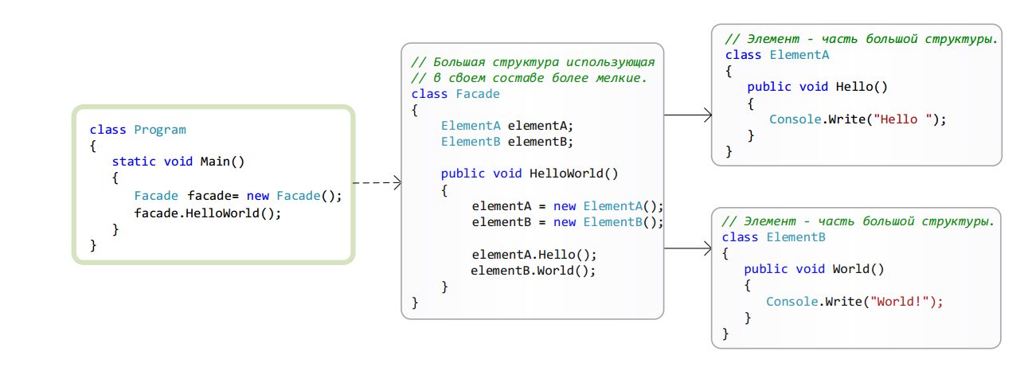

### Chain

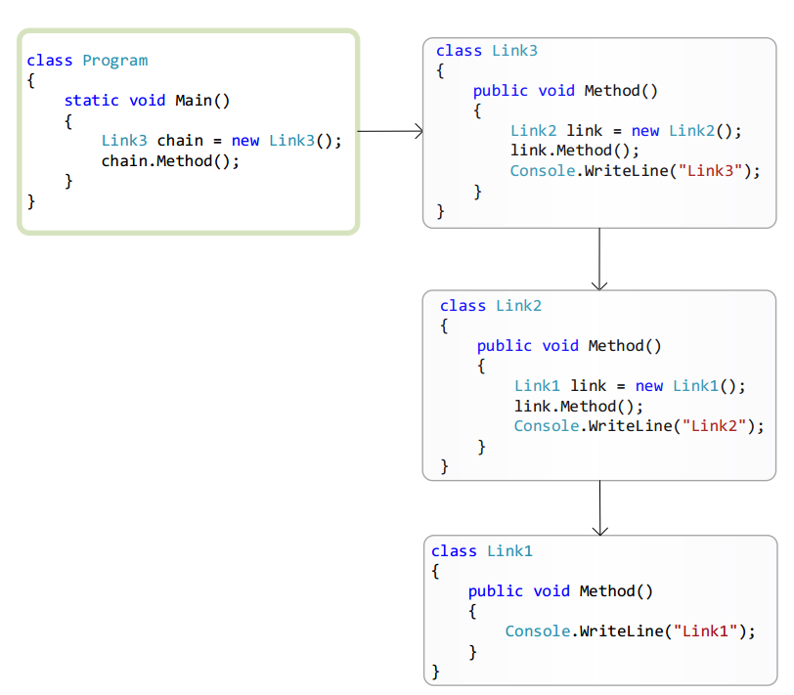

### Behavior

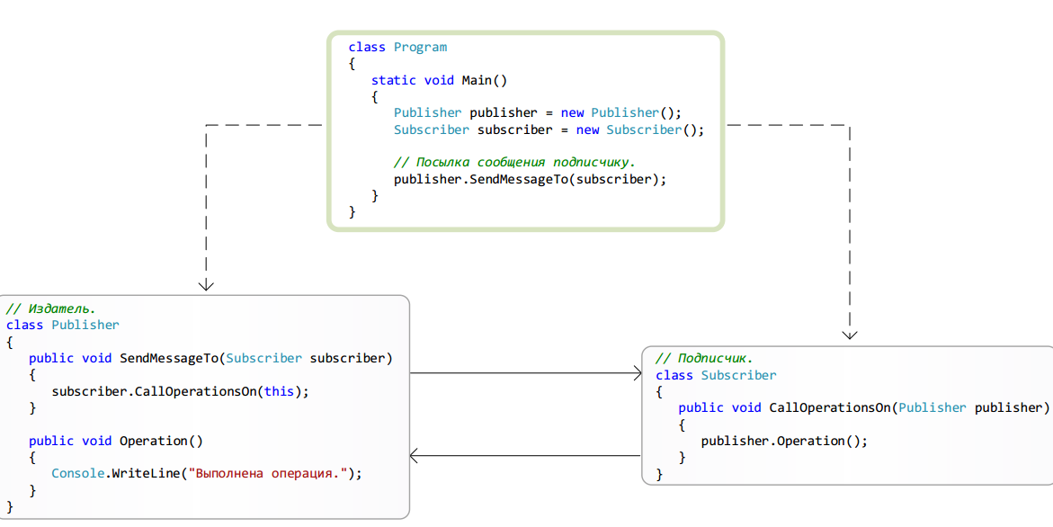

## Classification of patterns

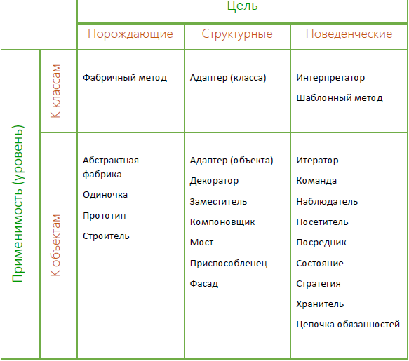

# Patterns

## Creating patterns

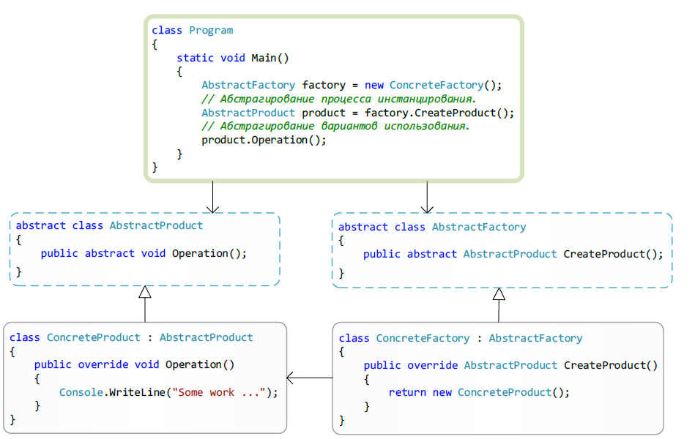

### Abstract Factory (Kit)

Real world example I need to create a lot of eliens by a lot a lot of different ways. And some parts are reusable and some parts are not reusable. So Some parts I will take from pool and some parts I will take not from pool. Abstract factory method same ME!!!

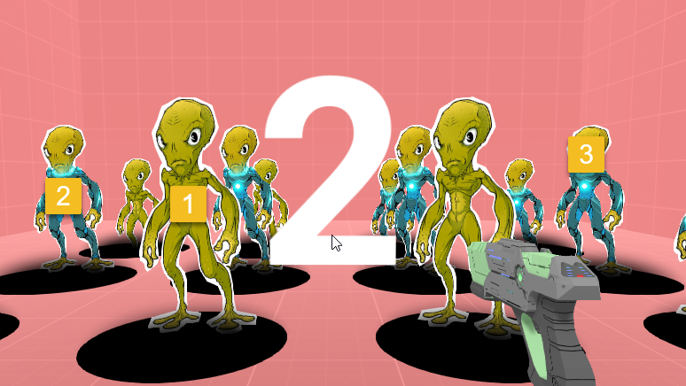

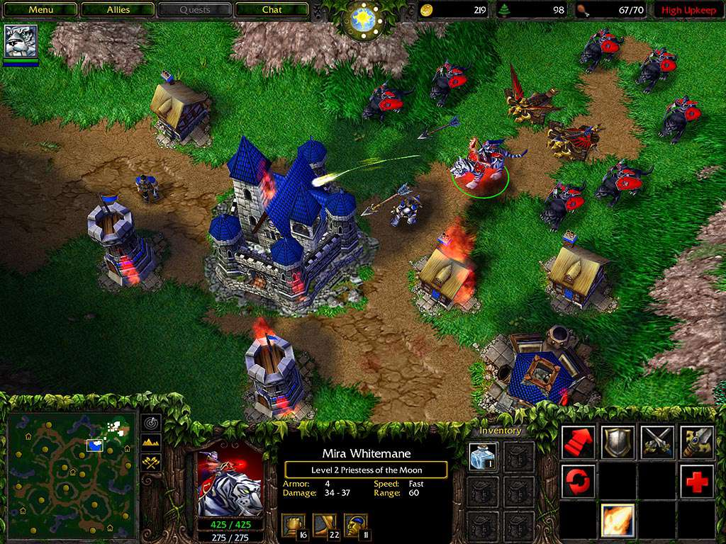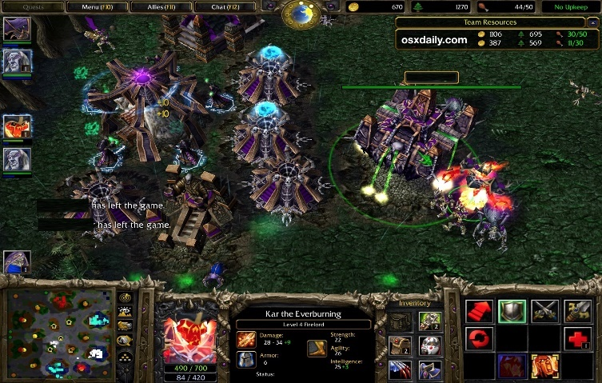

Different bases different units . But abstraction is the same.

Popularity 5.

Порождение семейств взаимодействующих продуктов.

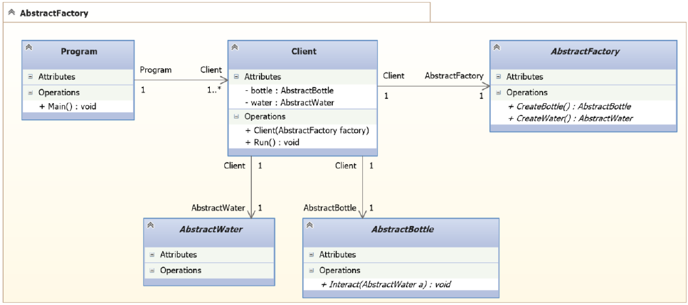

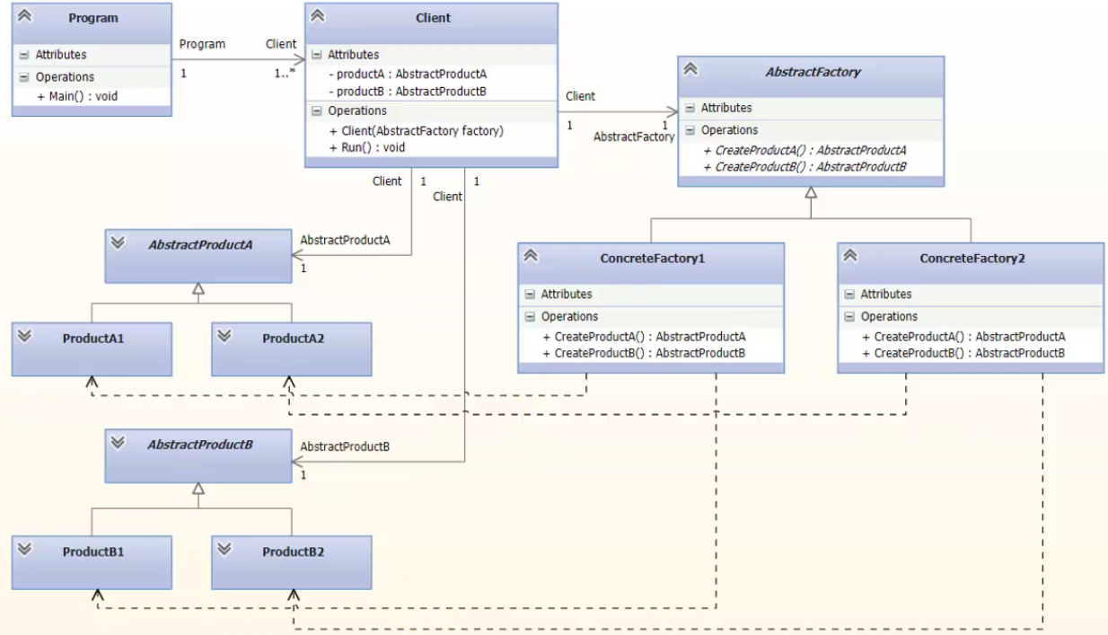

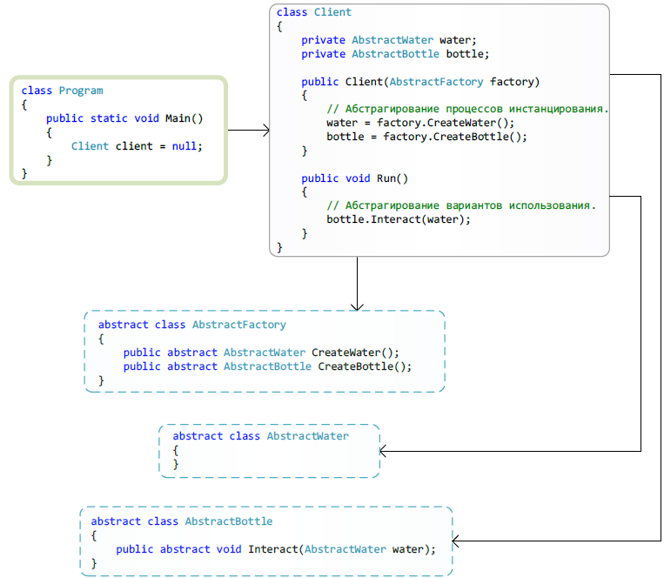

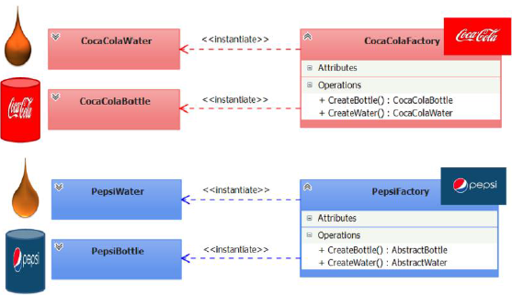

#### Using

1. Program in two styles where functionality is same but style is different
2. When we creating some subsystem inside our system what created from different products
3. Good example with maze Sometimes we need Enchanted parts of Maze and sometimes we need bombed parts of maze. So using this pattern we could easily create as many complicated maze as we need using the same client it is great!

#### Realizations

1. Only one example of Concrete factory in System
2. Abstract factory gives only interface of creating products. Products are created only inside the Concreate factory examples
3. Full Abstraction

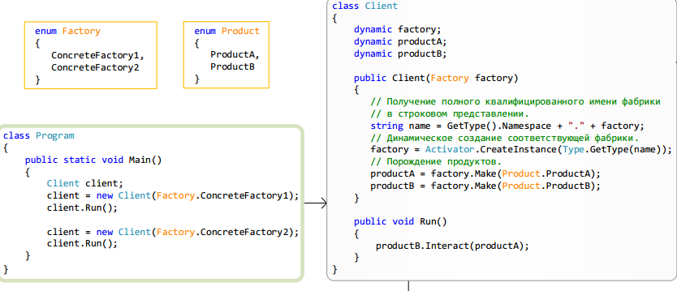

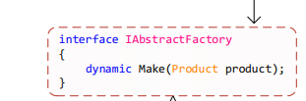

#### Example

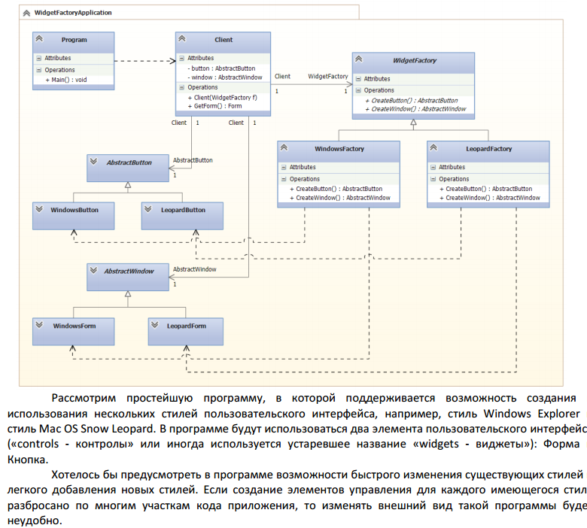

### Builder

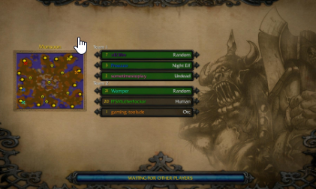

A simple you need create level but it based on a lot of diffrent things incide

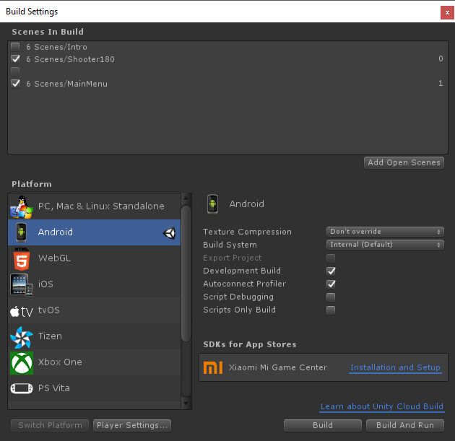

Unity project builder is great example api sdk models are the same but different platfroms have different requirements and opportunities.

Popularity 2

Паттерн Builder – помогает организовать пошаговое построение сложного объекта-продукта так, что клиенту не требуется понимать последовательность шагов и внутреннее устройство строящегося объекта- продукта, при этом в результате одного и того же процесса конструирования могут получаться объекты- продукты с различным представлением (внутренним устройством).

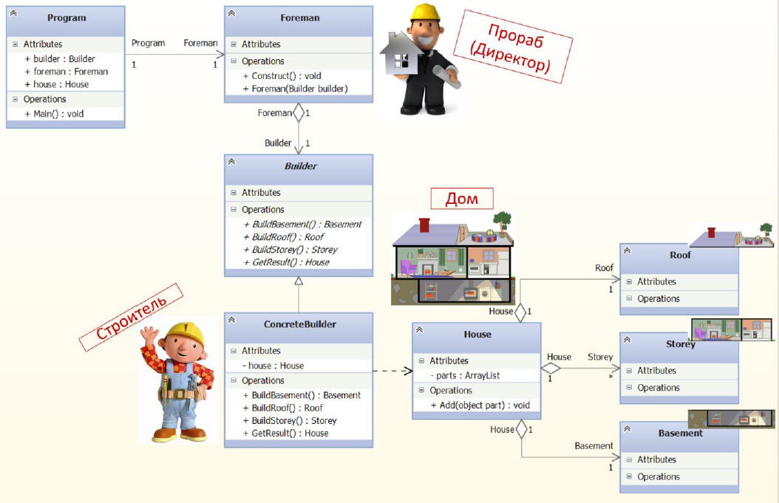

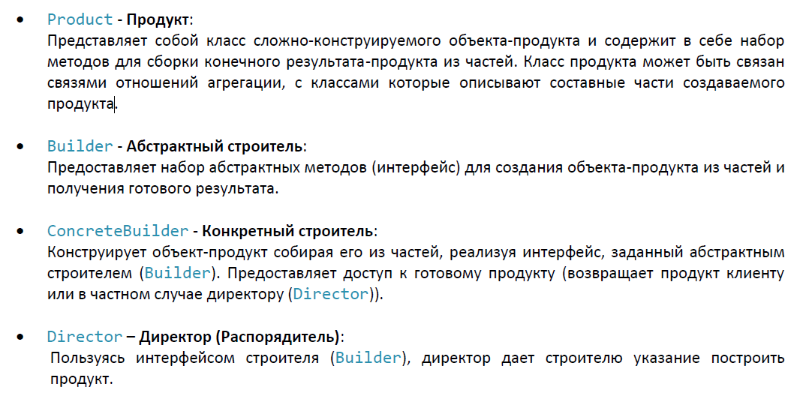

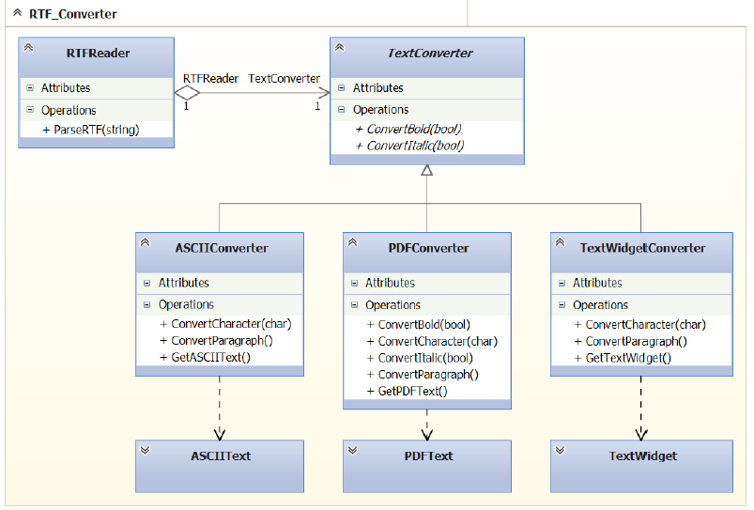

#### Using

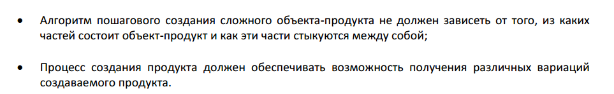

#### Realizations

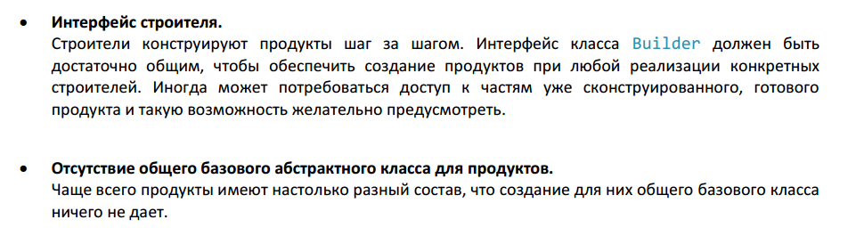

StringBuilder() – is good example

LevelBuilder() – is also good example for game dev

SceneBuilder() – is even better

#### Example

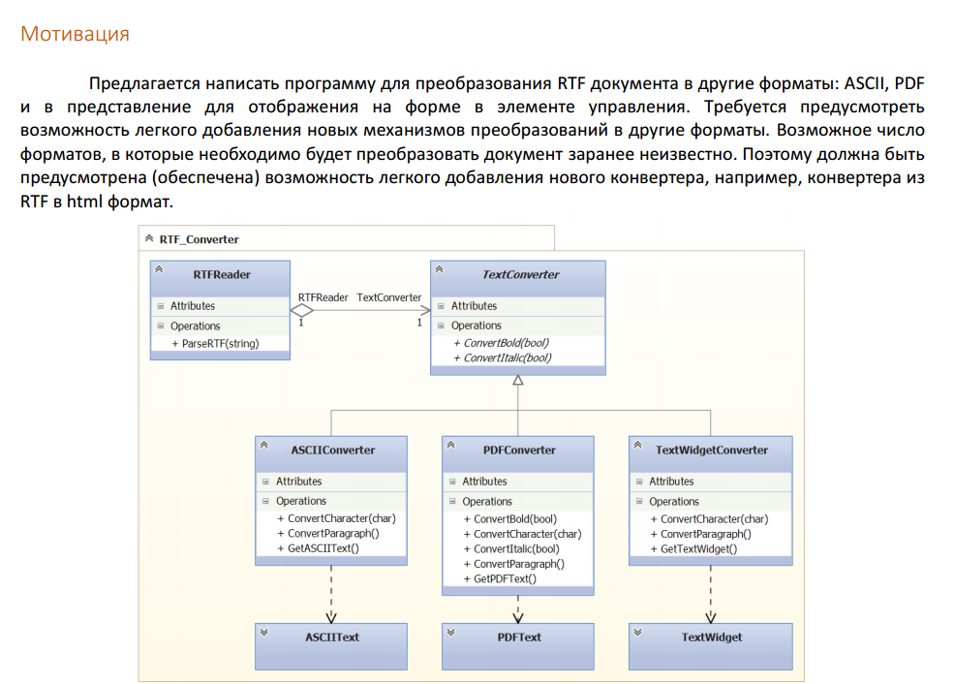

### Factory Method

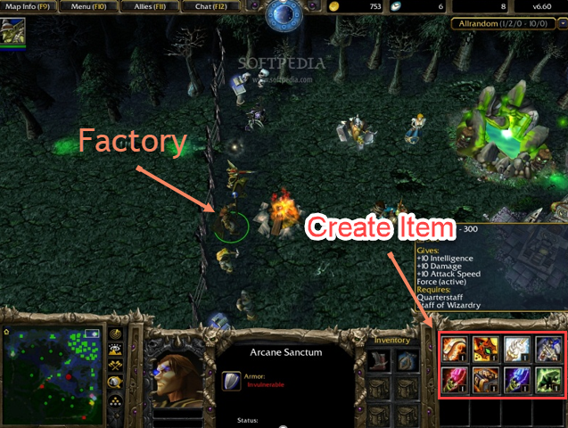

Popularity 5

Factory method – is base of all creatinal patterns if you couldn’t chose what Crational pattern you should use you could use Factory Method.

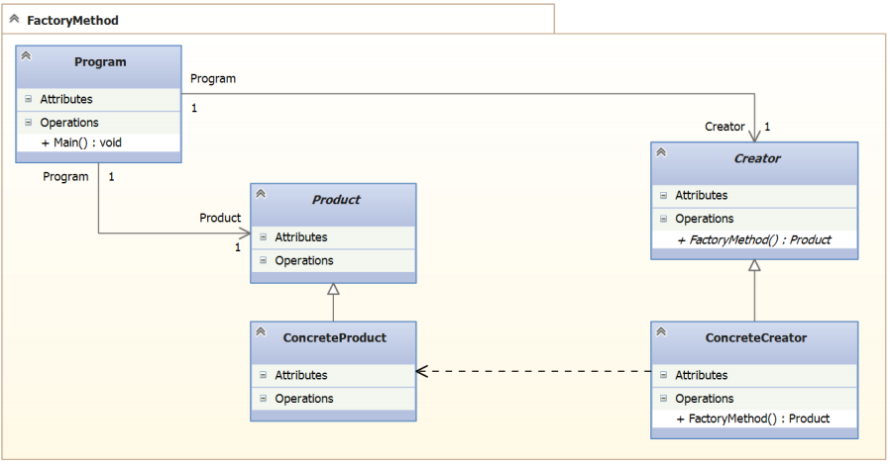

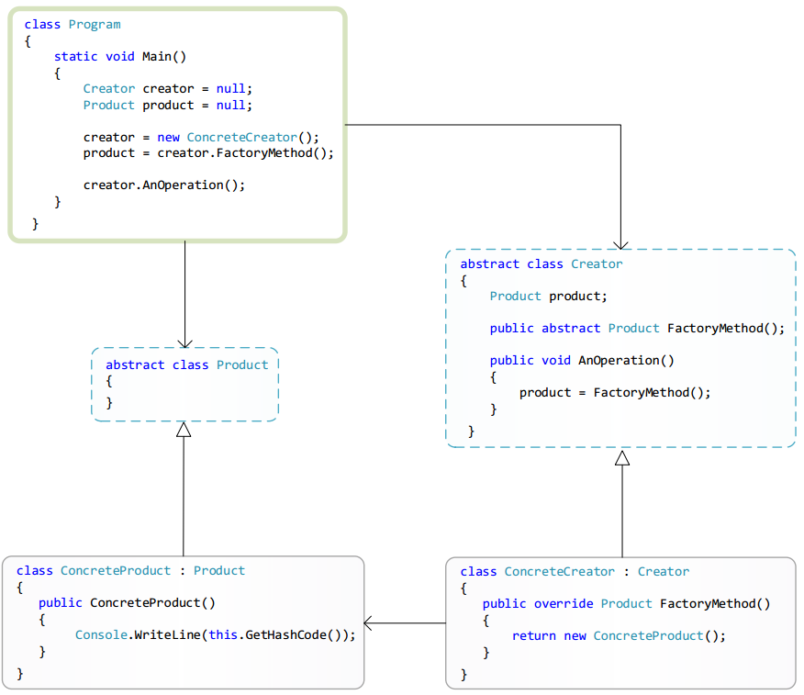

#### Example

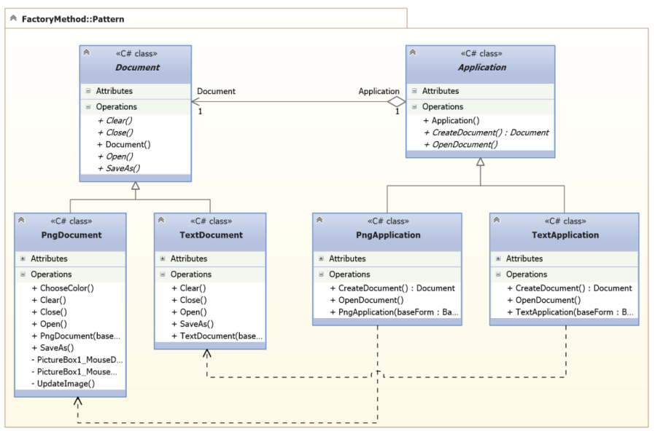

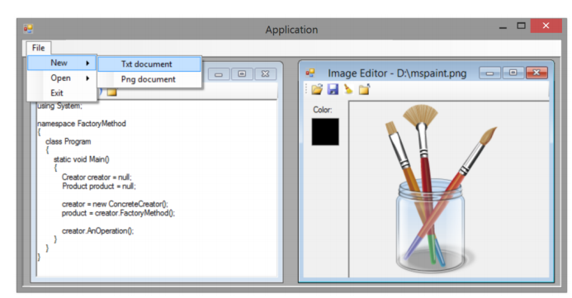

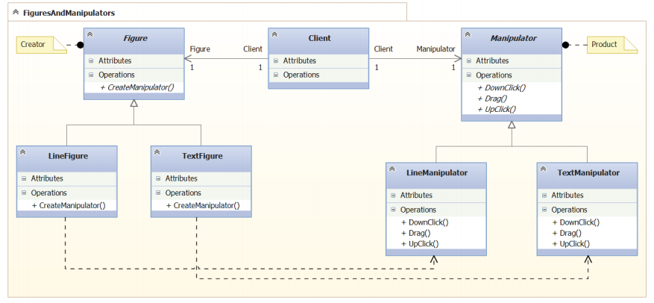

#### Using

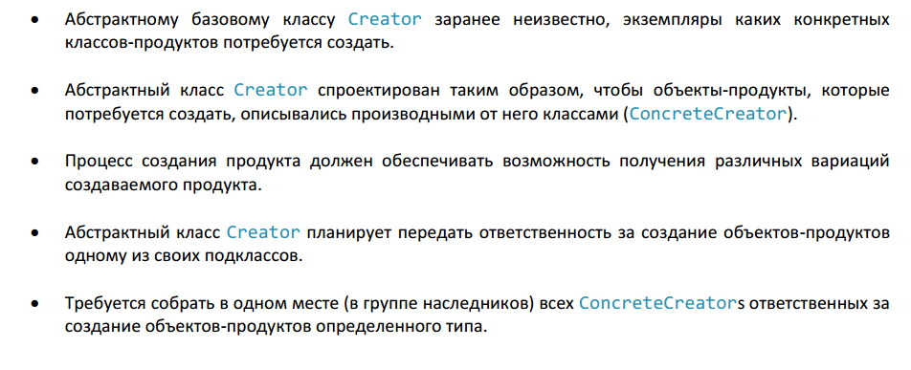

### Prototype(IClonable)

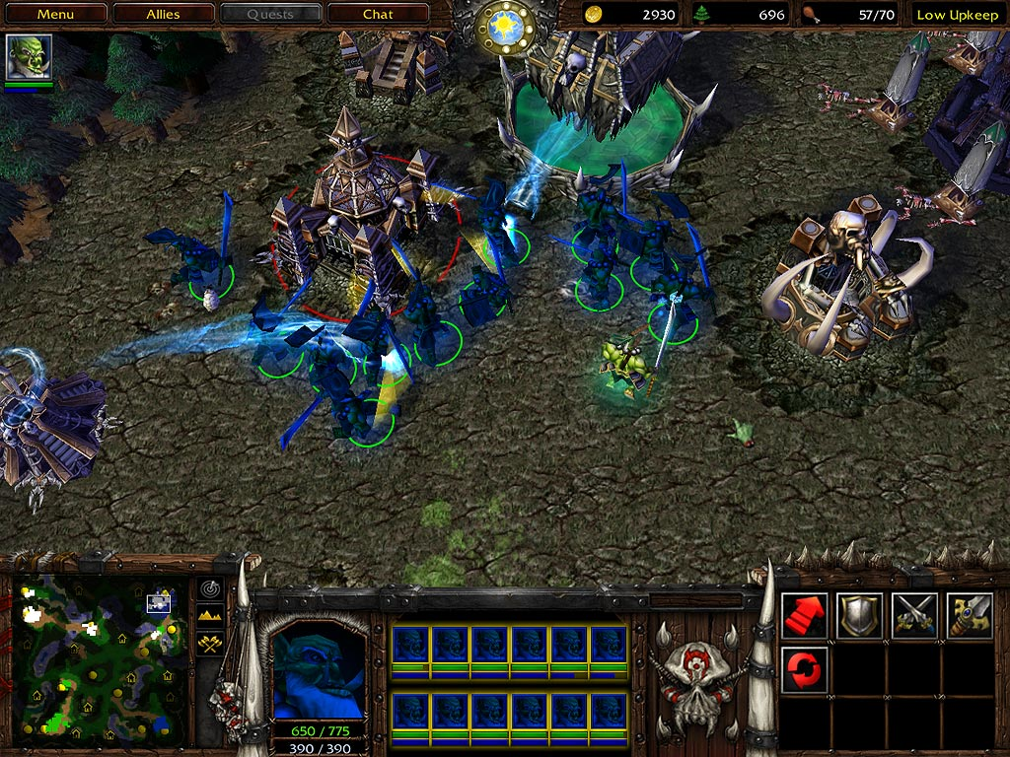

We need to clone existing item or character.

Popularity 3

Prototype – is patterns that we use for cloning the object using his prototype often in C# we use the IConable.

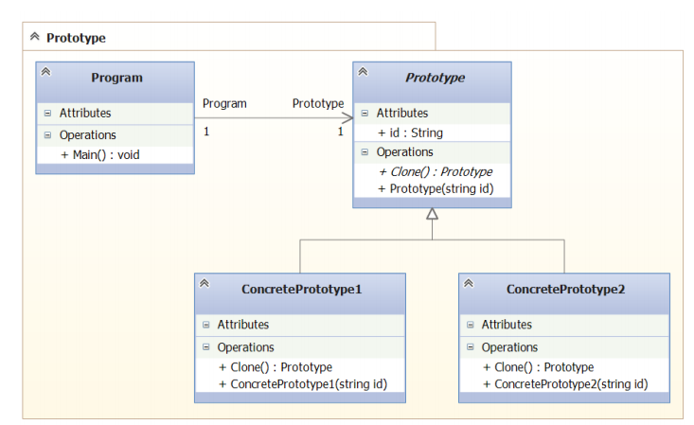

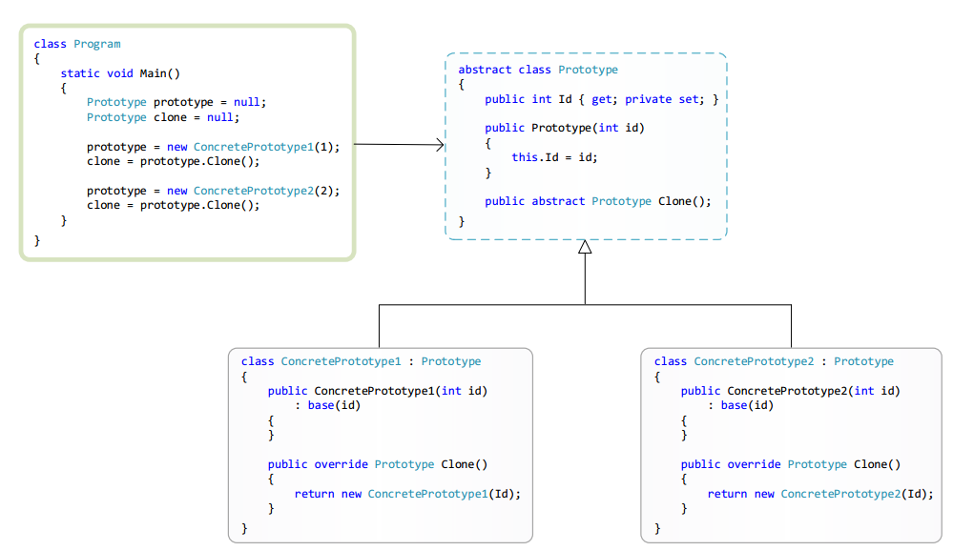

### Singleton

Give us gurranty that will exist only one instance

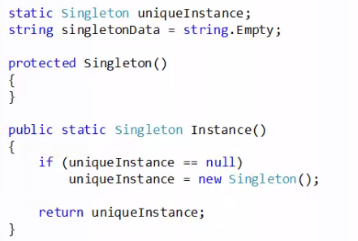

## Structure patterns

Are used for creating right structure of class hierarchy

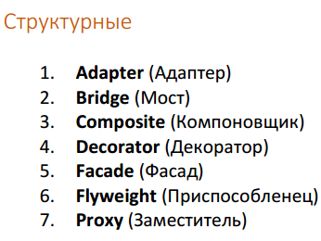

### Adapter

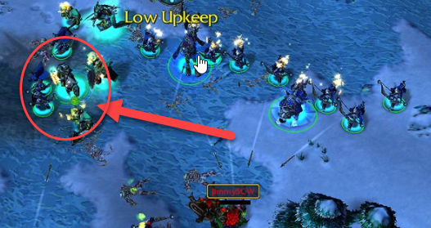

Control Enemy units.

We use adapter when we have no opportunity to use class as other class

Poplurity 4

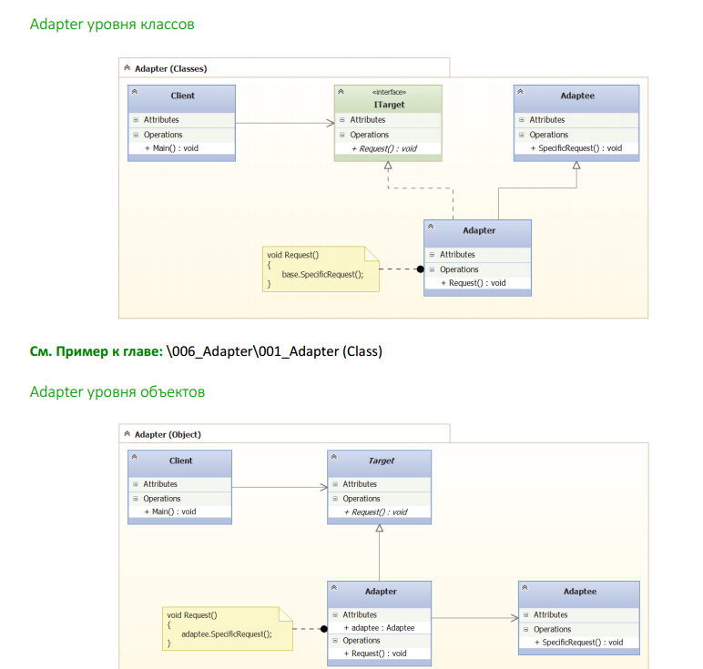

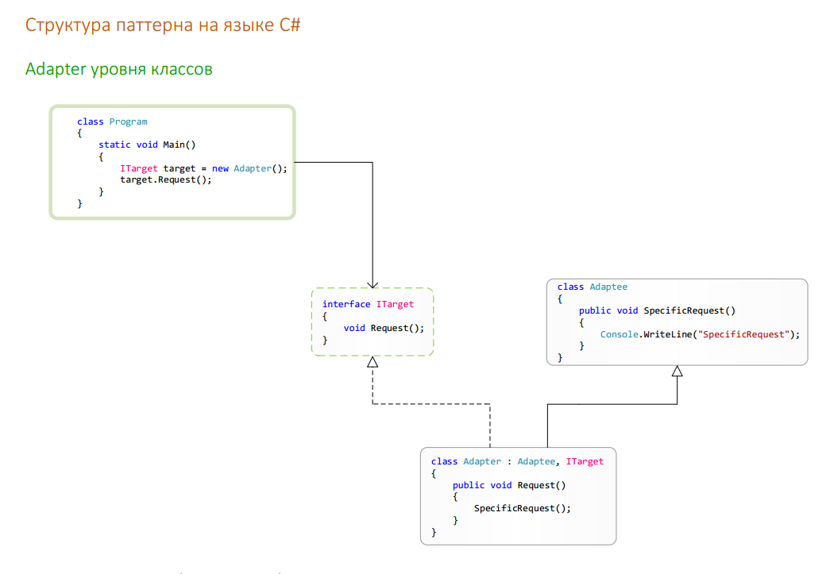

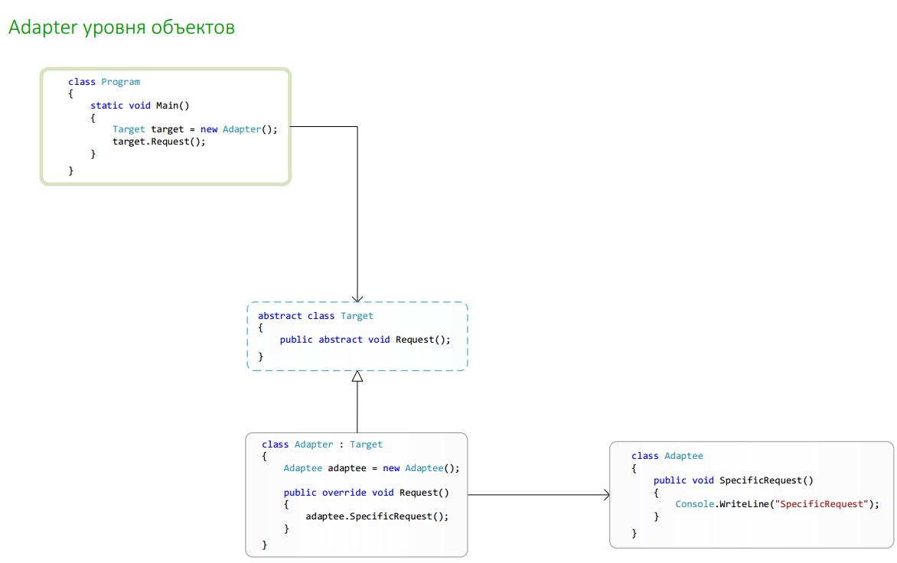

#### Motivation

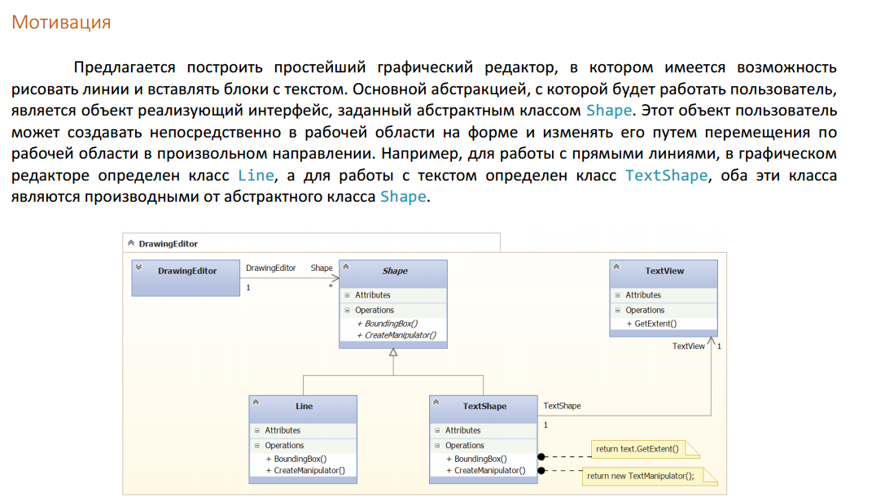

#### Usage

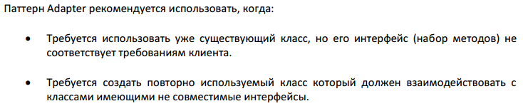

#### Realizations

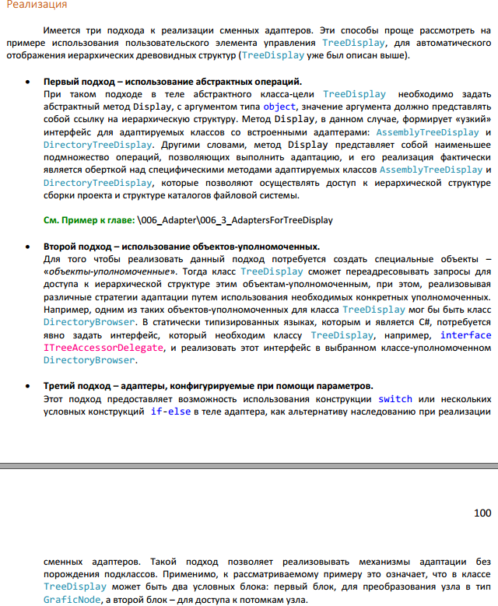

### Proxy

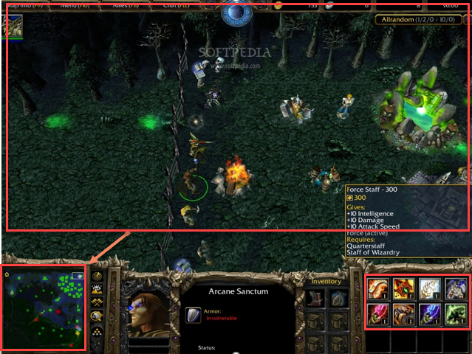

Minimap in WarCarft 3 So it is proxy to the bigger map and translate commands to the big map and reflect events from the big map

Popularity 4

We use proxy when we can use our class by it self or through proxy no diffrence

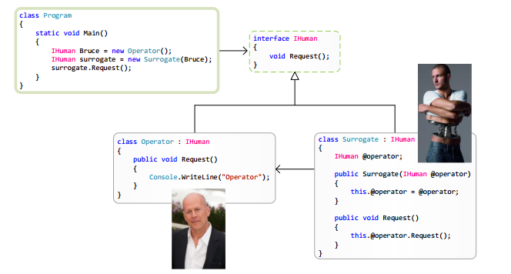

#### C# Implementation

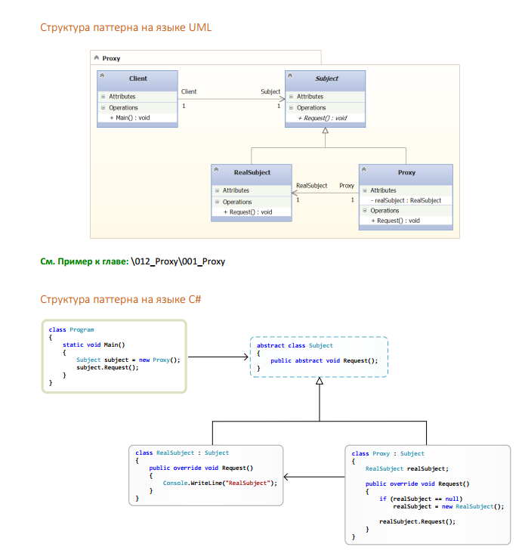

#### Motivation

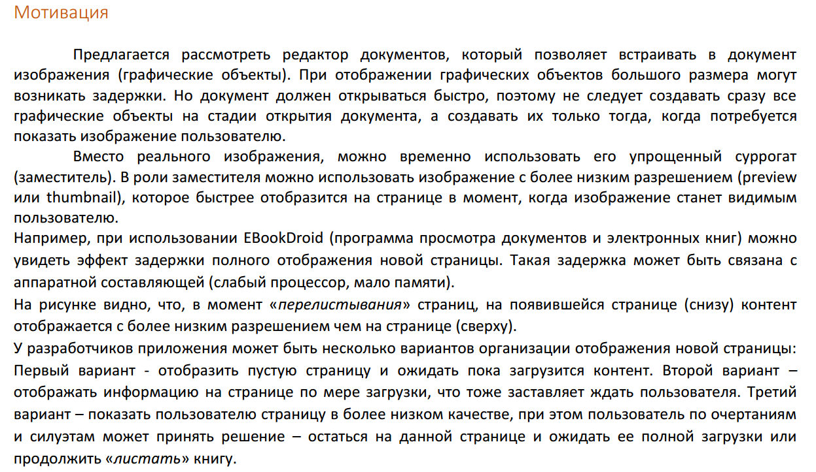

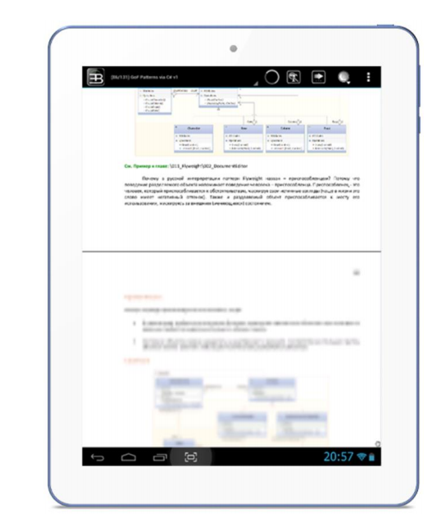

#### Realizations

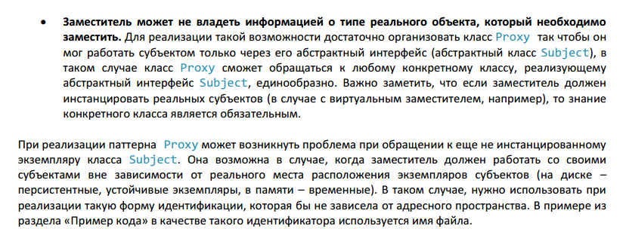

### Bridge

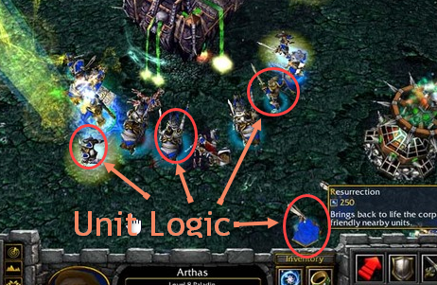

Different Units have difrent visual and animator realization but abstract logic is the same.

Паттерн Bridge – позволяет отделить абстракцию от элементов ее реализации так, чтобы и  
абстракцию, и реализацию

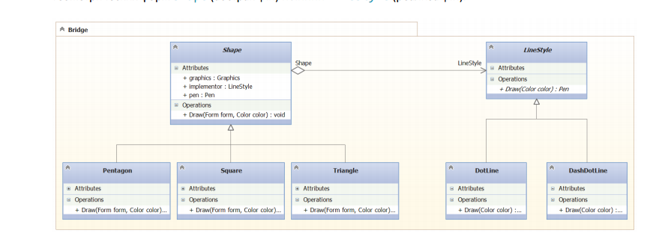

#### C# Implementation

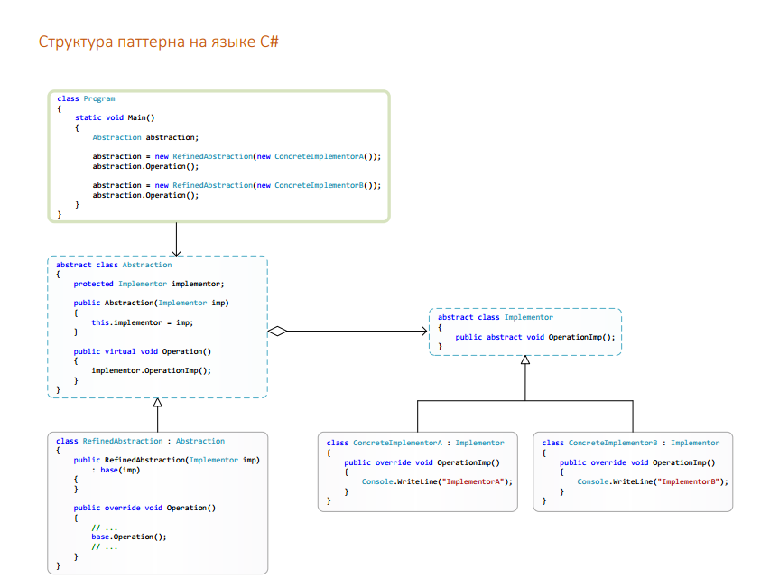

#### UML Implementation

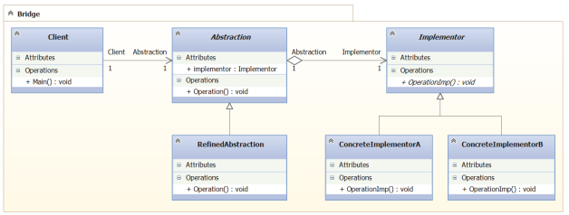

#### Motivation

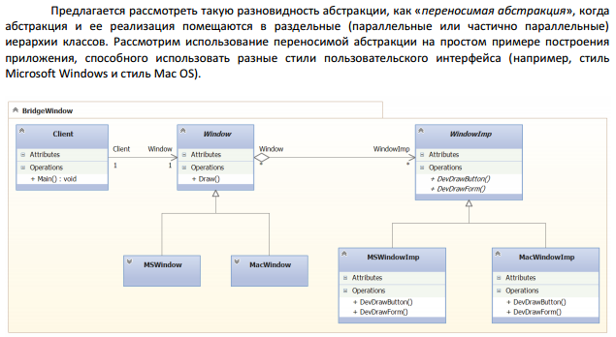\

#### Usage

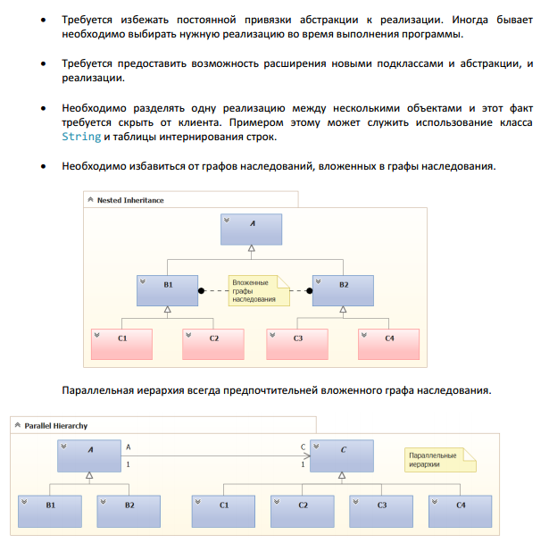

#### Realizations

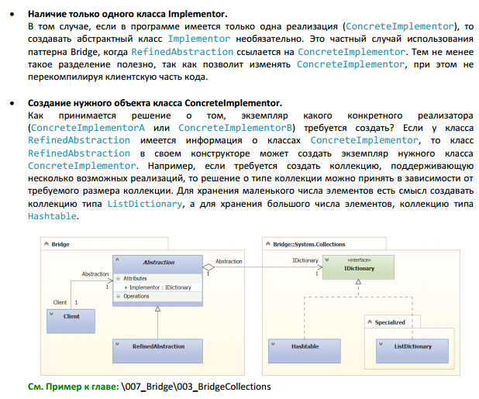

### Composite

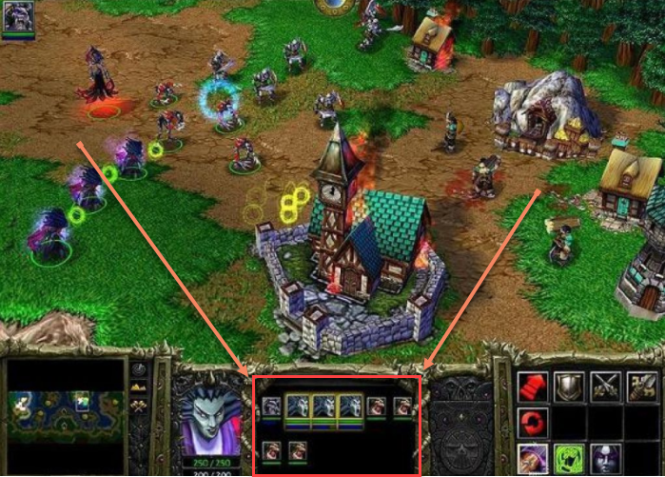

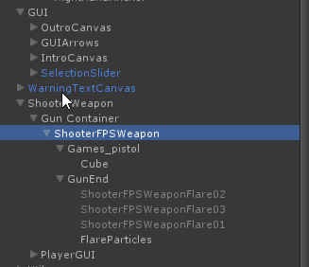

Unity Hierarch is great example

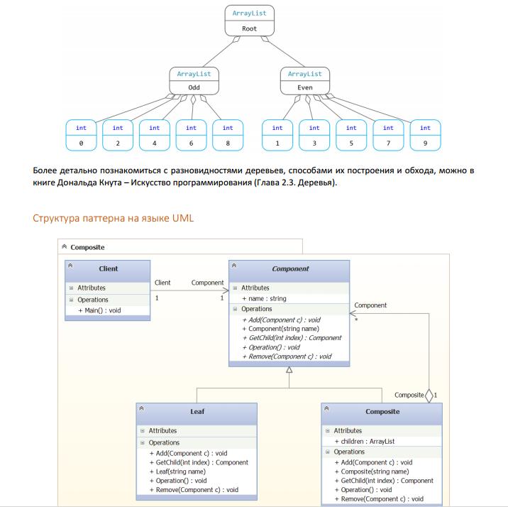

#### C# Implementation

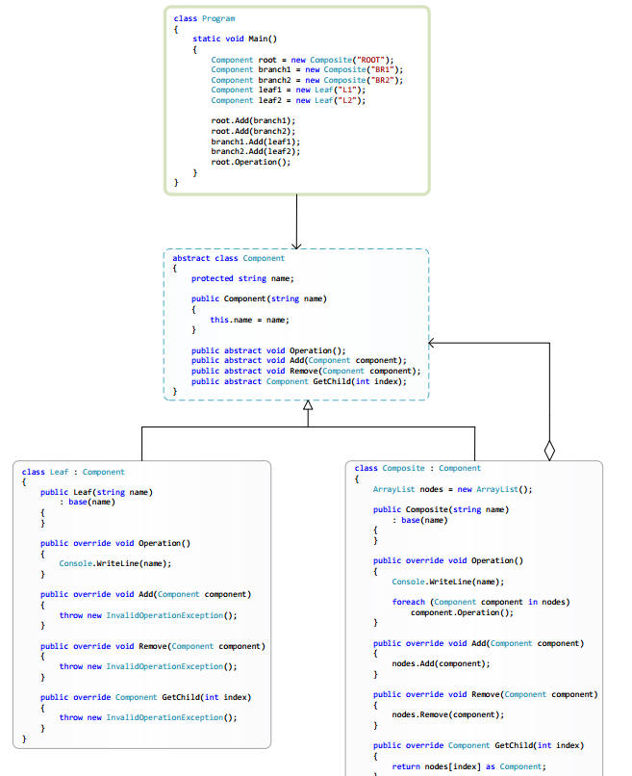

#### Motivation

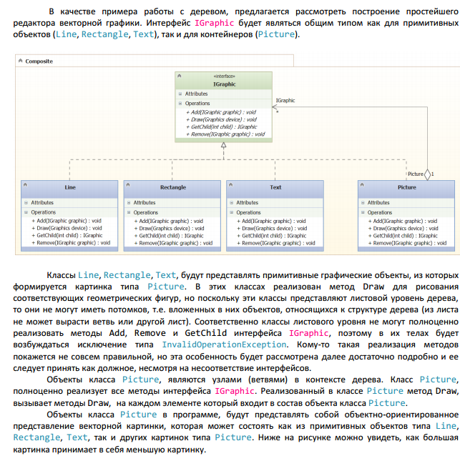

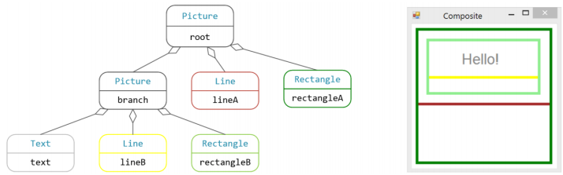

#### Usage

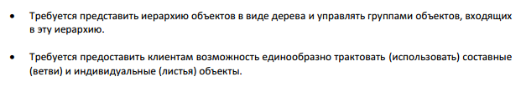

#### Realizations

#### 

#### 

#### In Net

#### 

### Decorator

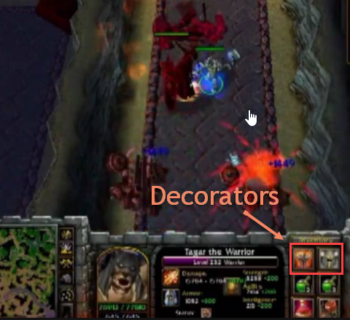

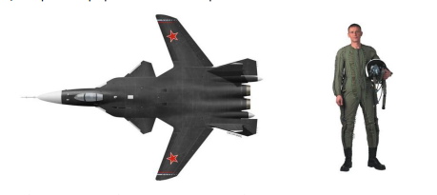

Динамически (в ходе выполнения программы) добавляет объекту новые  
возможности (состояние и/или поведение). 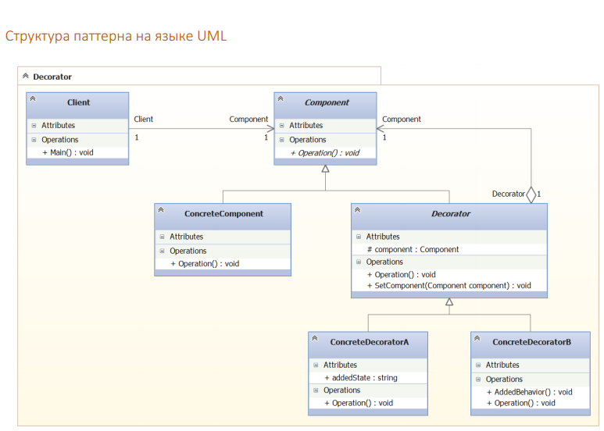

#### C# Implementration

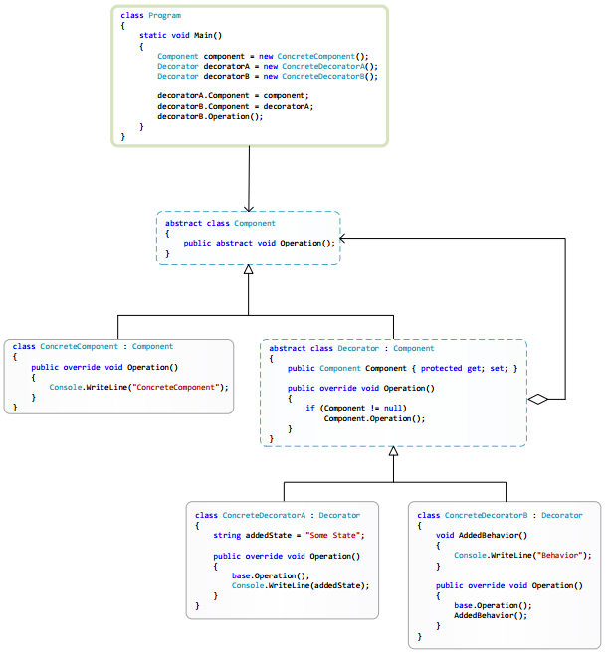

#### Motivation

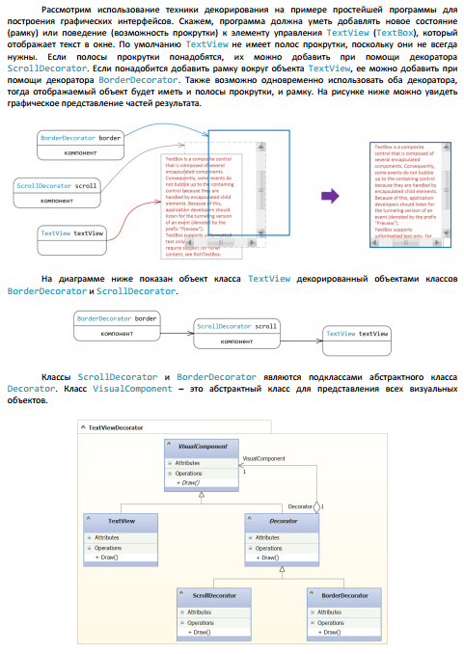

#### Realization

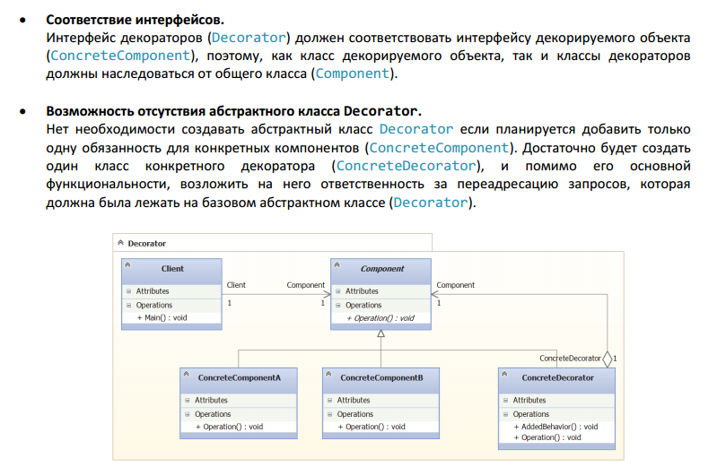

### Faсade

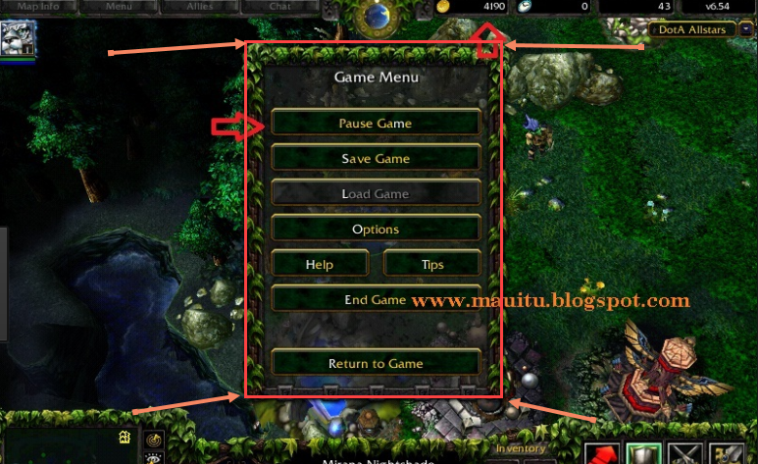

Popularity 5

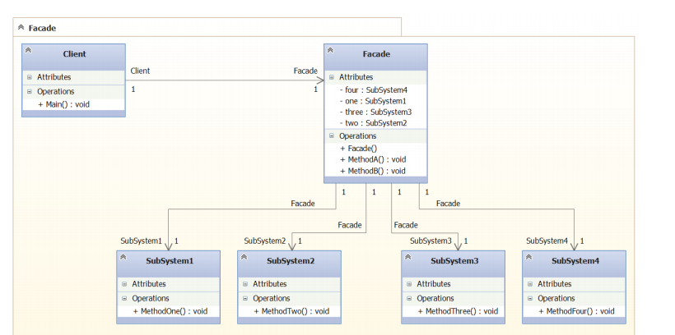

#### C# Implementation



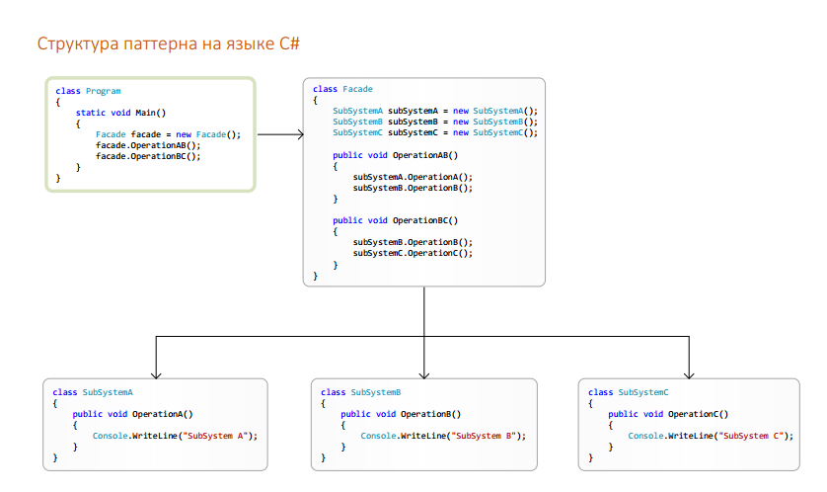

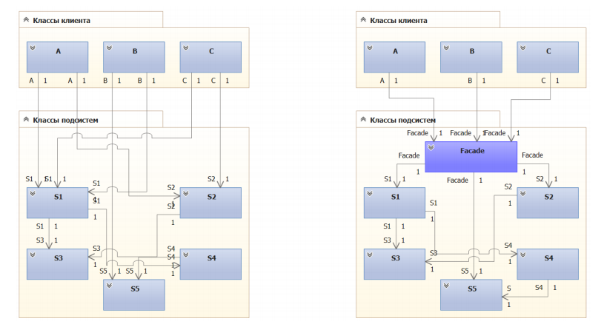

#### Usage

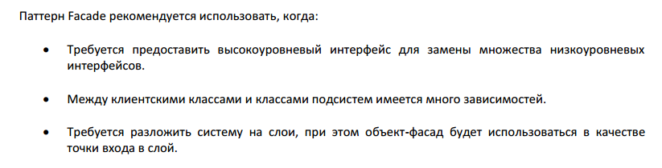

#### Realization

### Flyweight

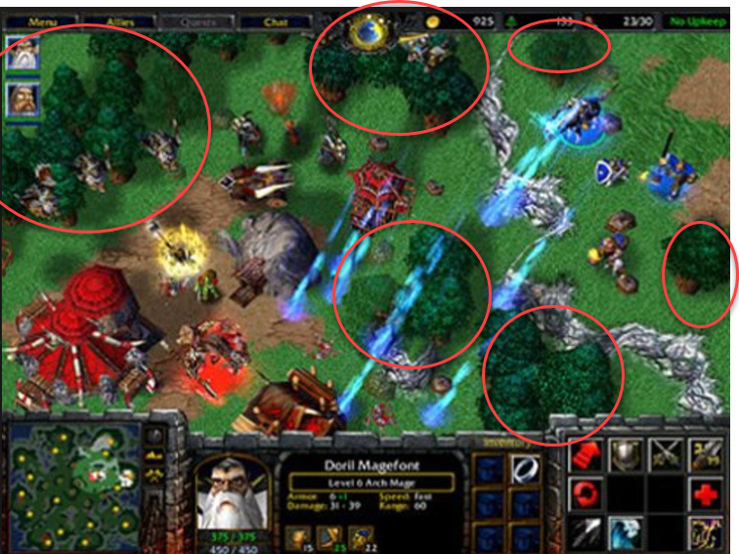

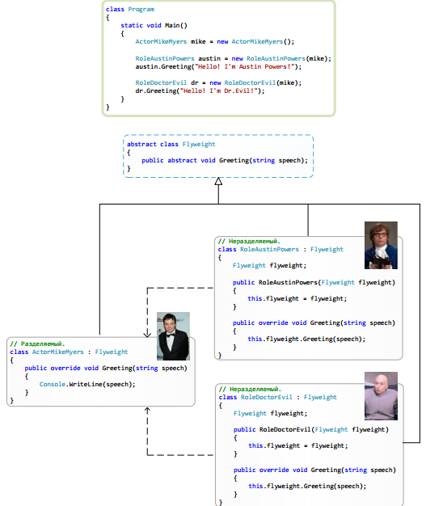

#### UML

#### C# Implementration

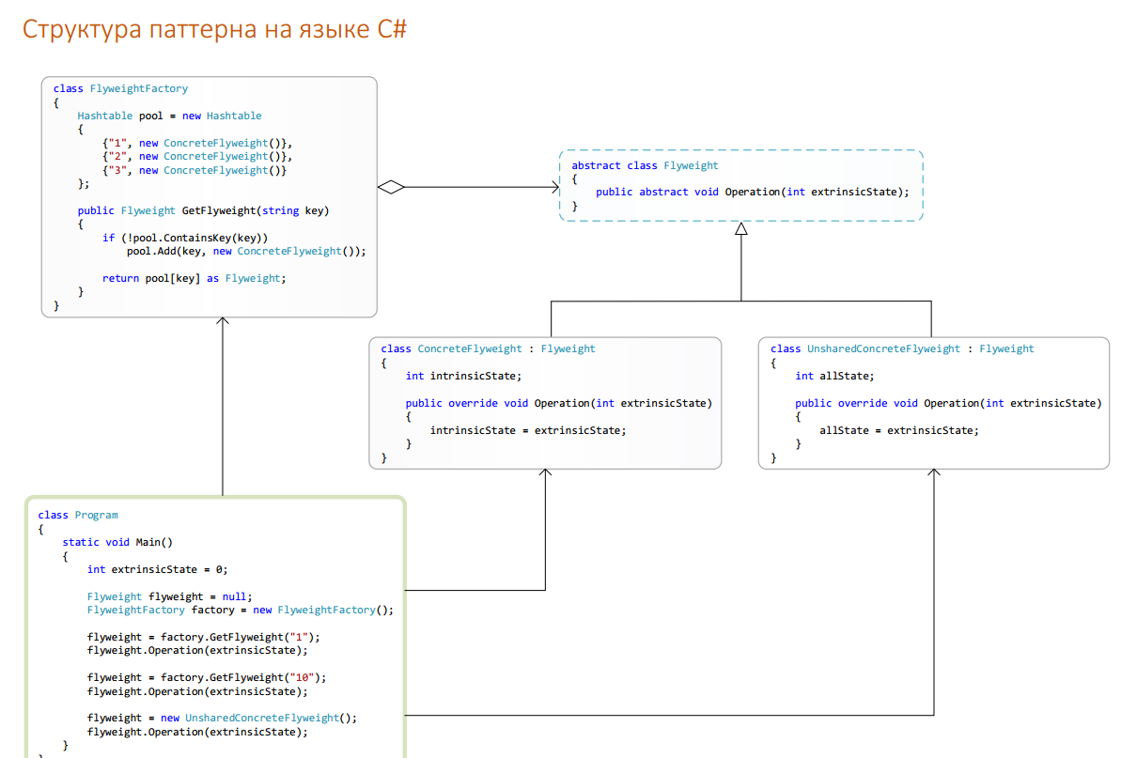

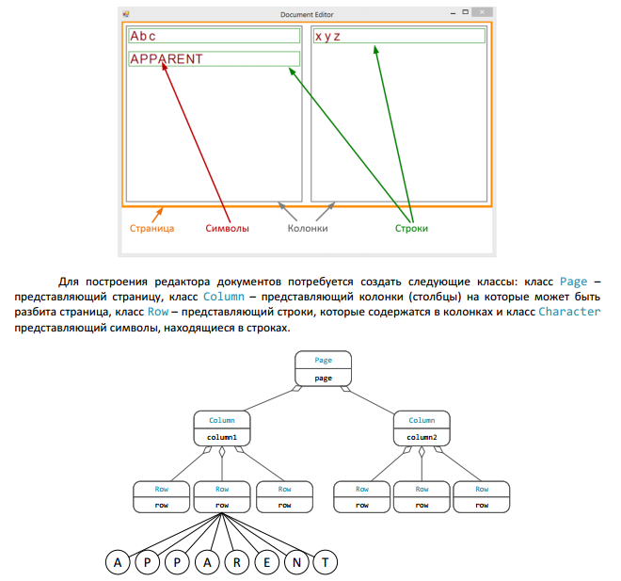

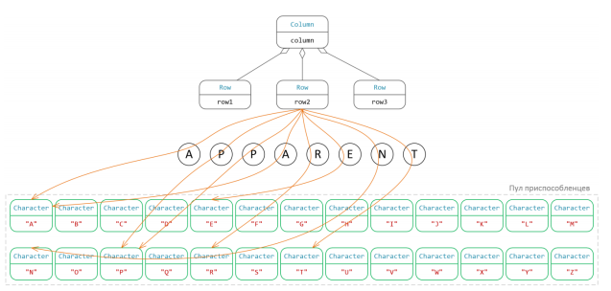

## Behavior patterns

### Chain of Responsibility

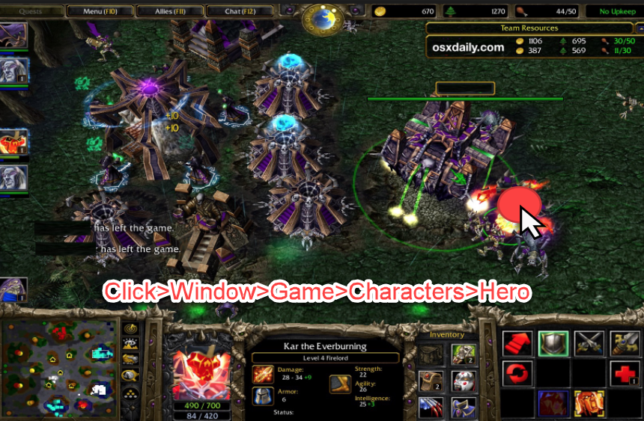

Using for attacking one by one

Popularity 2.

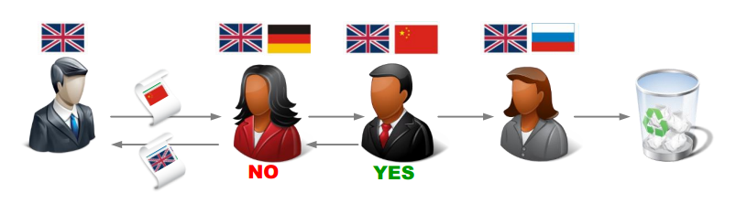

#### UML Structure

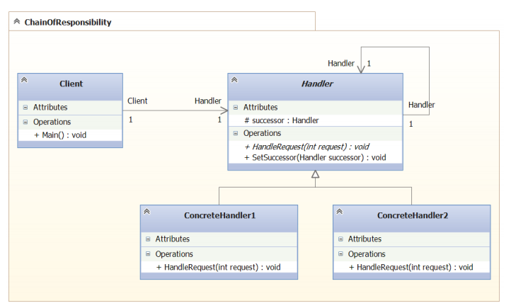

#### C# structure

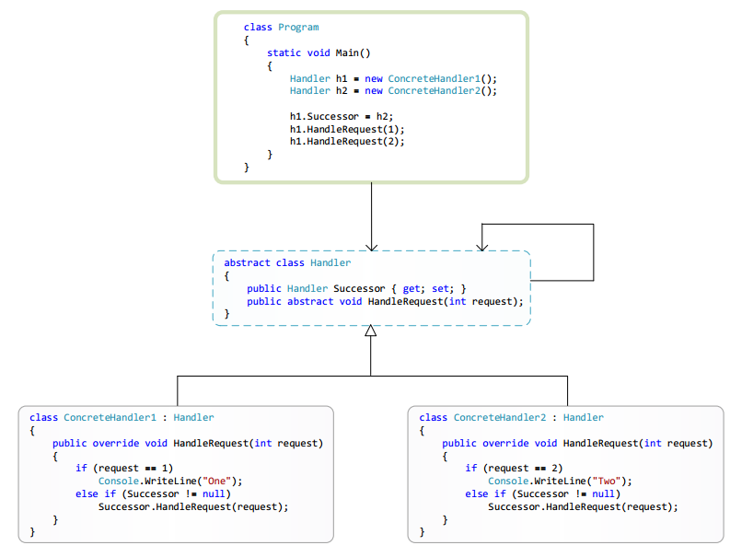

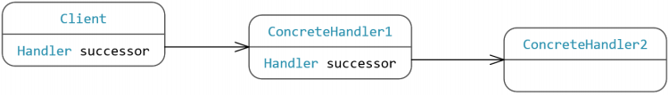

#### Usage

* в разрабатываемой системе имеется группа объектов, которые могут обрабатывать сообщения определенного типа;
* все сообщения должны быть обработаны хотя бы одним объектом системы;
* сообщения в системе обрабатываются по схеме «обработай сам либо перешли другому», то есть одни сообщения обрабатываются на том уровне, где они получены, а другие пересылаются объектам иного уровня.

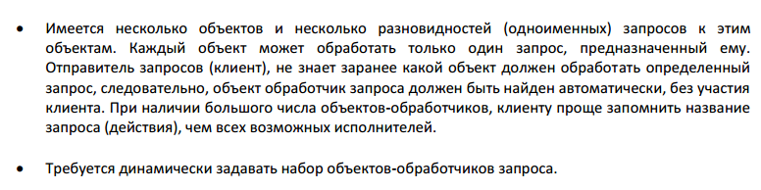

#### Realizations

* Использовать существующие связи между объектами (например, между кнопкой и формой на  
  которой она размещена, существует связь через свойство Parent)
* Определить новые связи (через свойство Successor реализованное в абстрактном классе  
  Handler, и, возможно, переопределенное в конкретных классах-наследниках  
  ConcreteHandler1 и ConcreteHandler2).
* 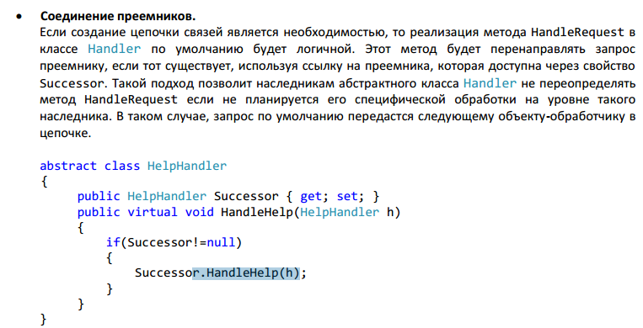

### Command

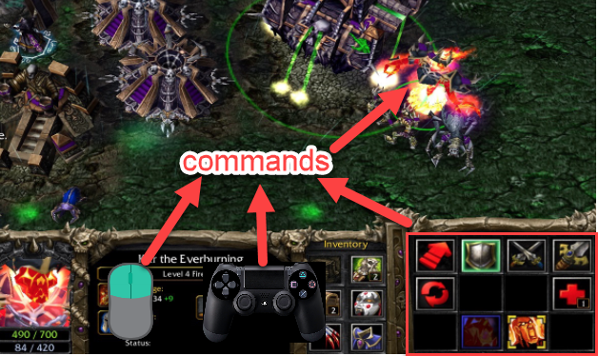

Паттерн Command – позволяет представить запрос в виде объекта, позволяя клиенту  
конфигурировать запрос (задавая параметры для его обработки), ставить запросы в очередь,  
протоколировать запросы, а также поддерживать отмену операций.

#### Calculator example

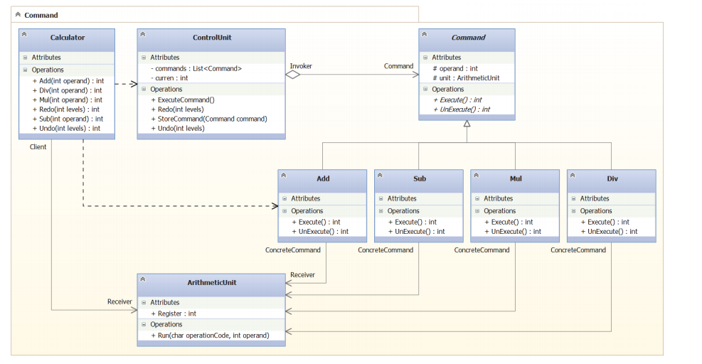

#### UML

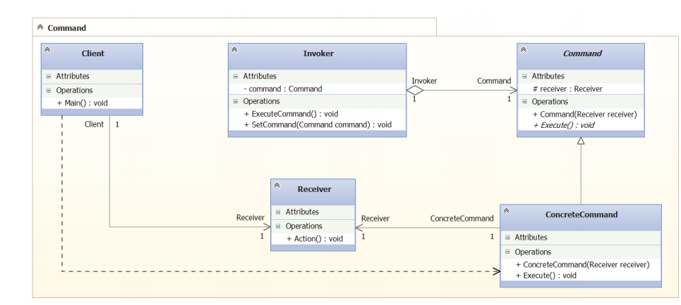

#### C#

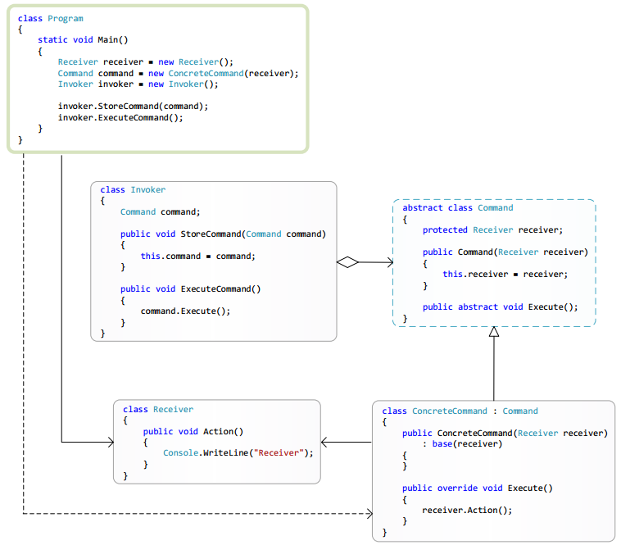

#### Motivation

Ctrl+C

Context menu

Menu

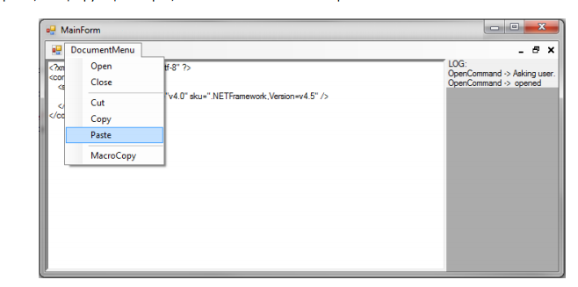

Call complectated command

#### Usage

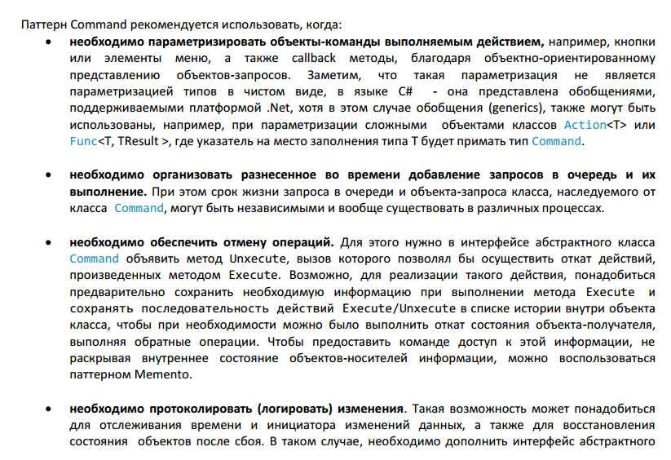

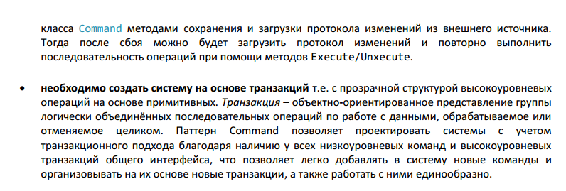

#### Realizations

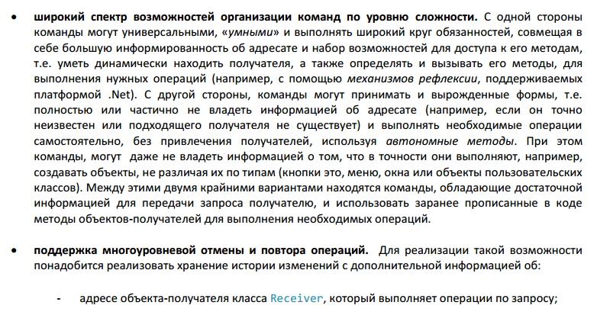

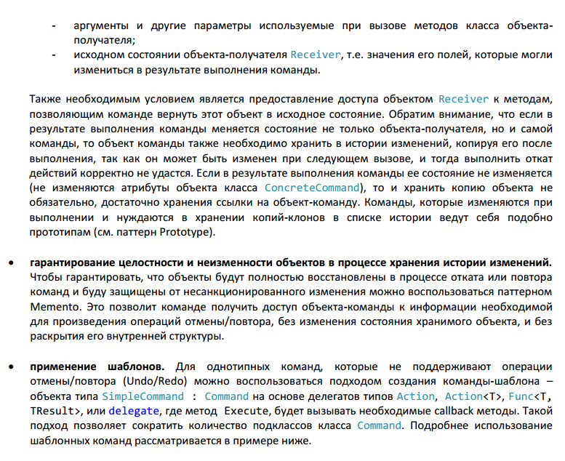

### Interpreter

Popularity:0

Паттерн Interpreter – позволяет сформировать объектно-ориентированное представление  
грамматики для заданного языка, а также описывает правила создания механизма интерпретации  
(*толкования*) предложений этого языка.

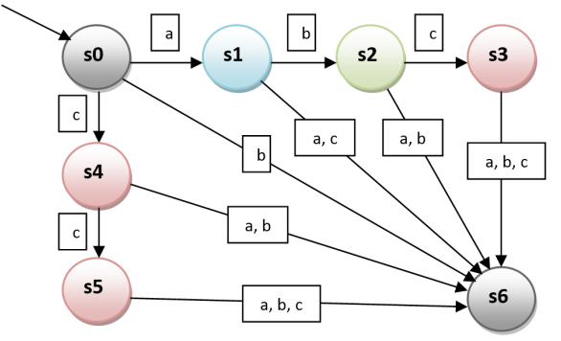

#### UML

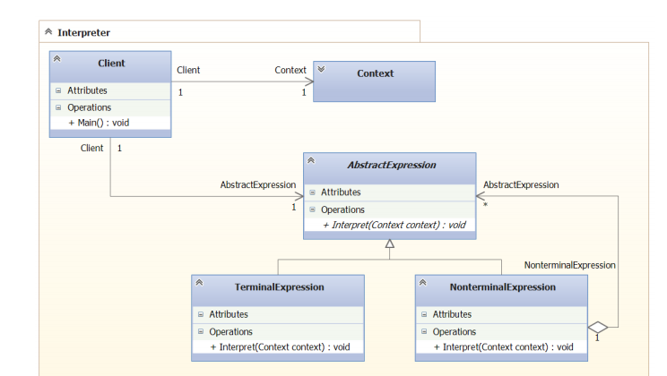

#### C#

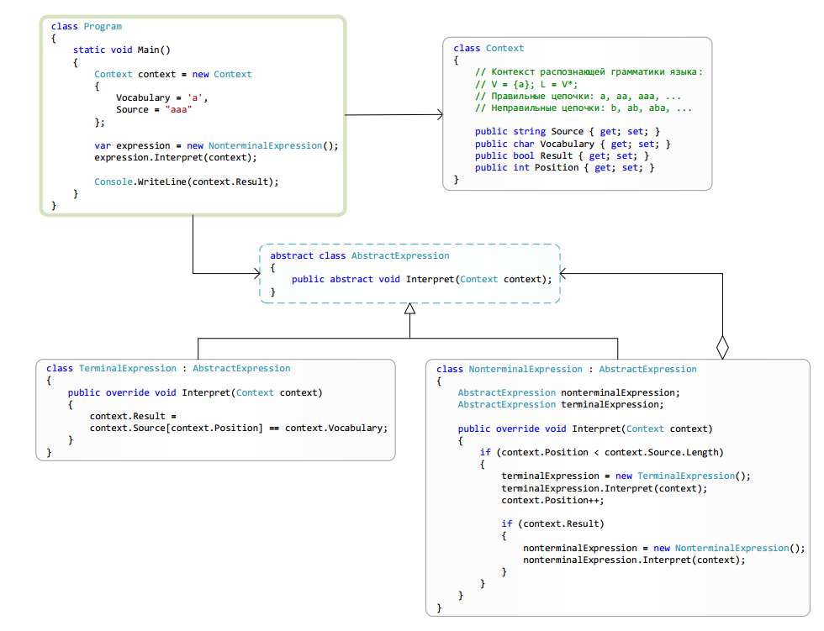

### Iterator

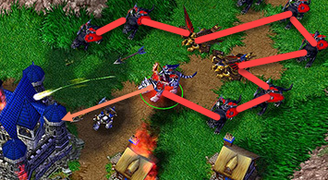

Iterato all army to set each unit to attack

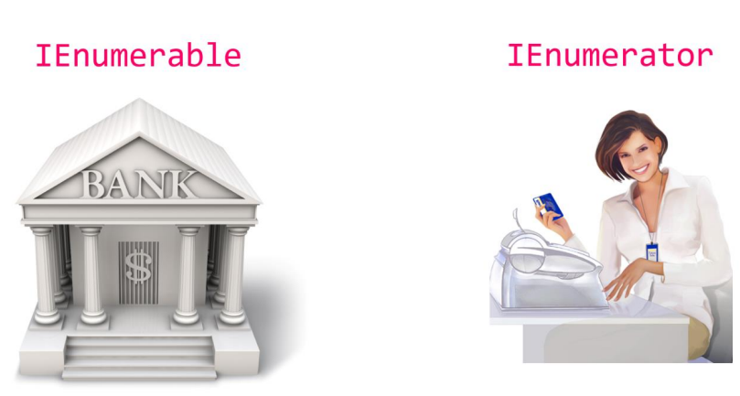

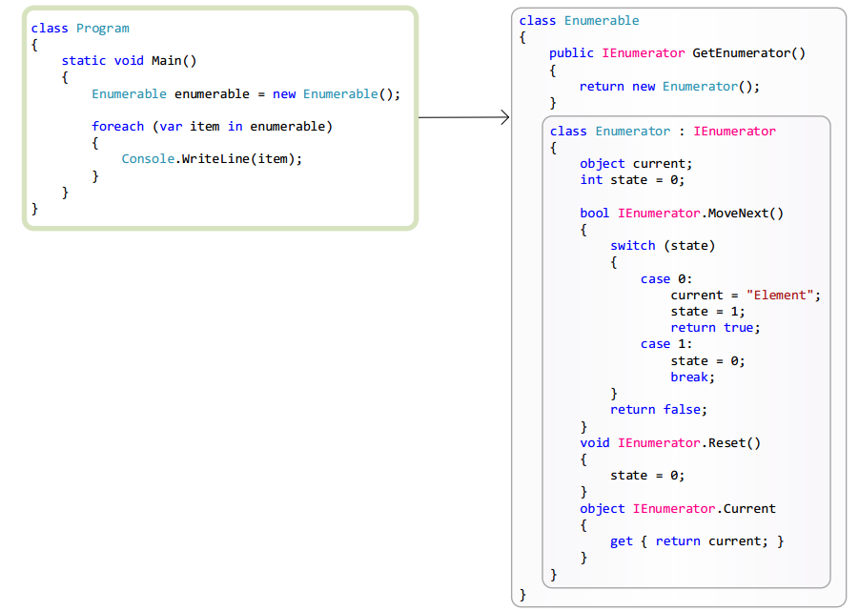

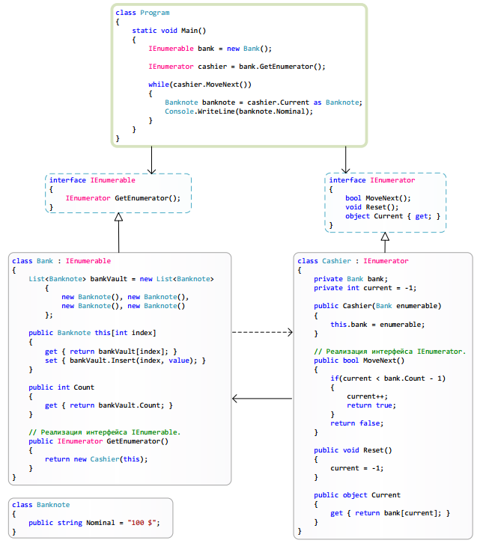

#### IComponent IContaintainer ISite

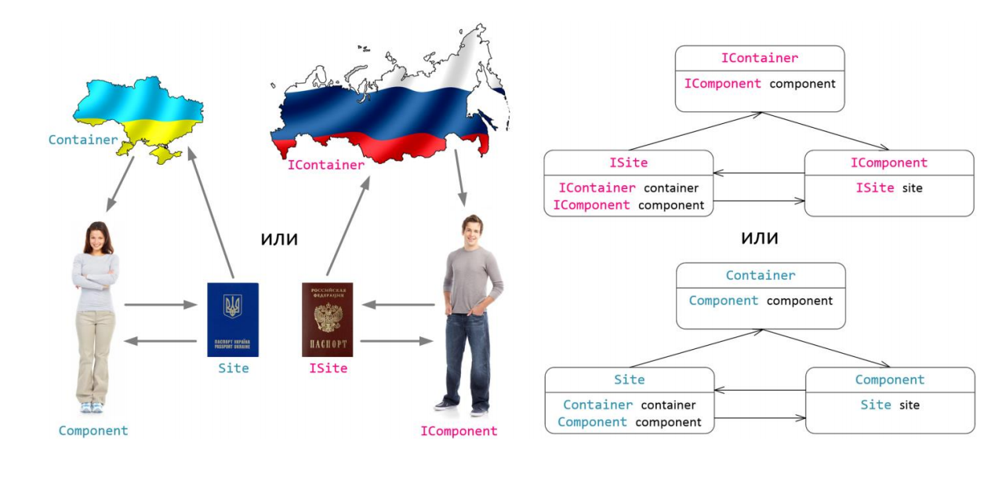

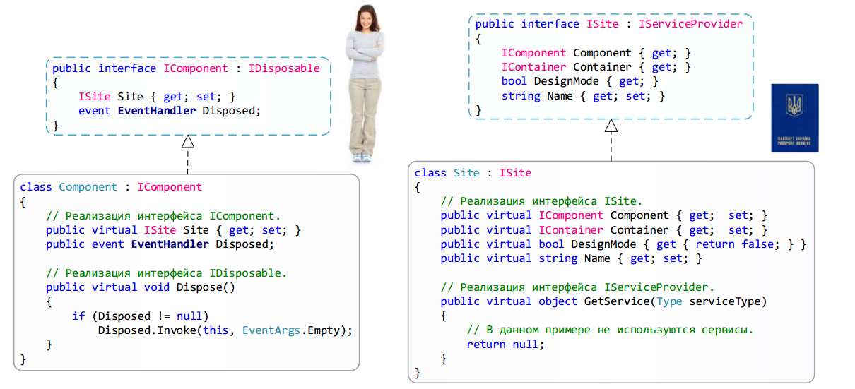

#### ICollecion

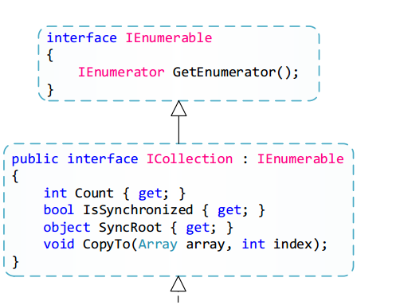

#### IList

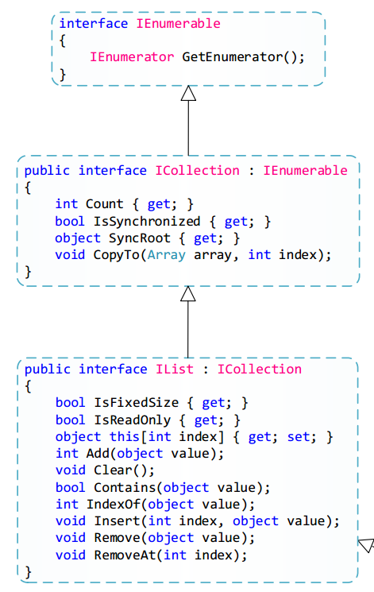

#### UML

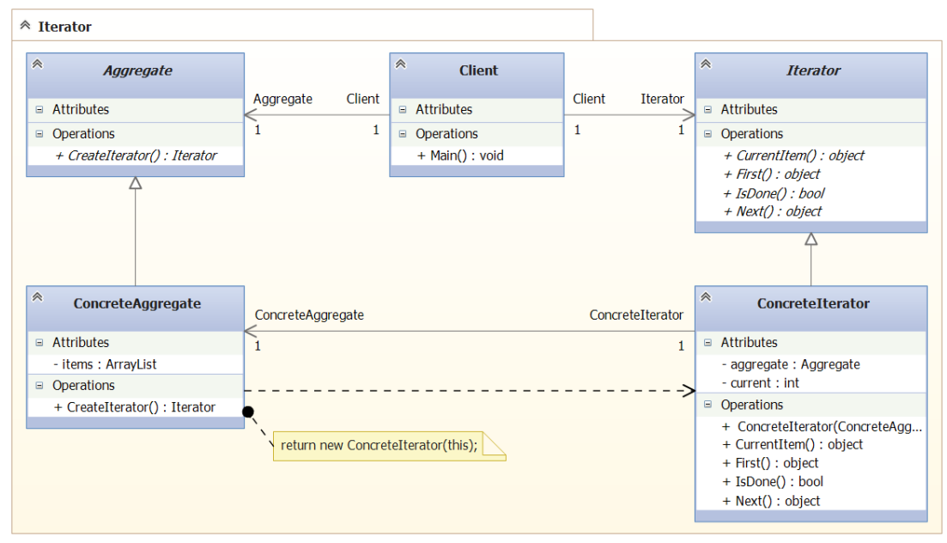

#### UML .NET

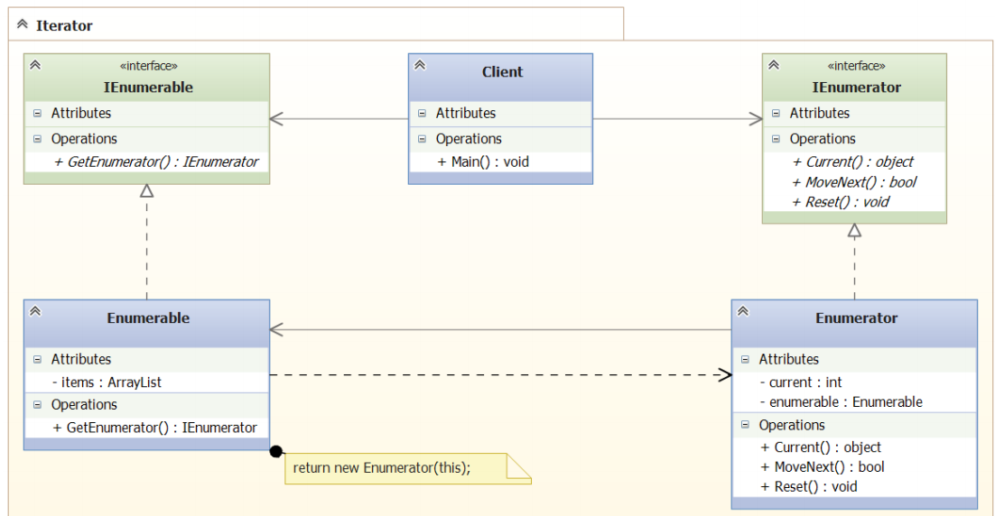

### Mediator

Popularity 2

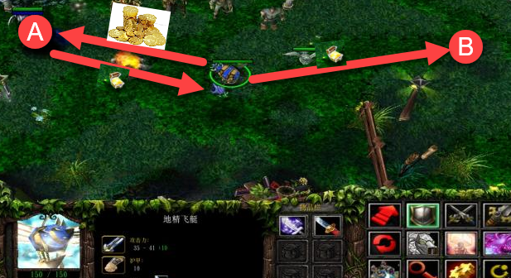

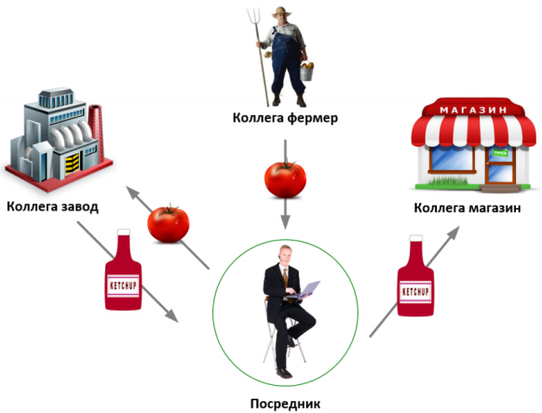

#### UML

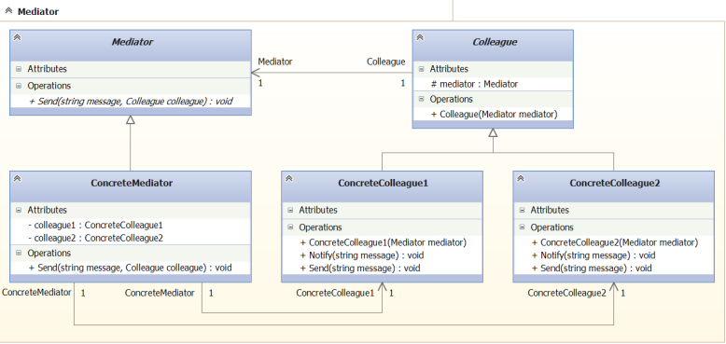

#### C#

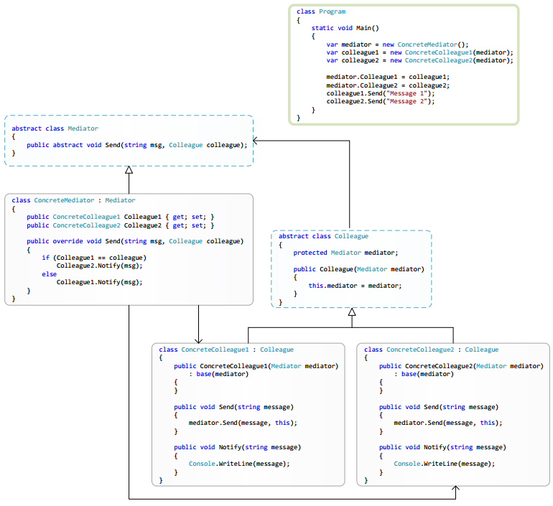

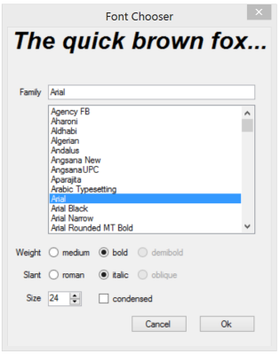

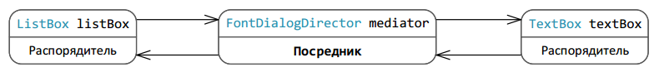

#### Usage

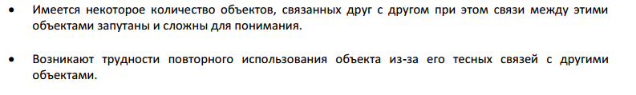

### Memento

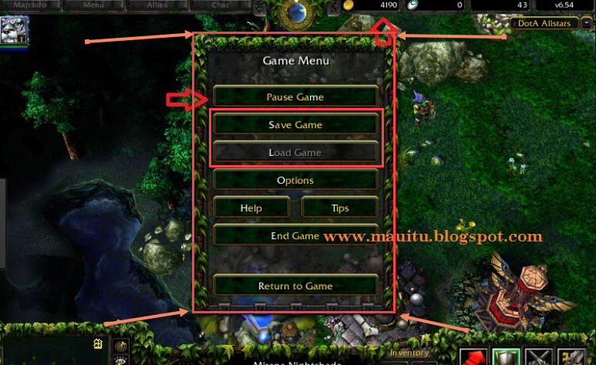

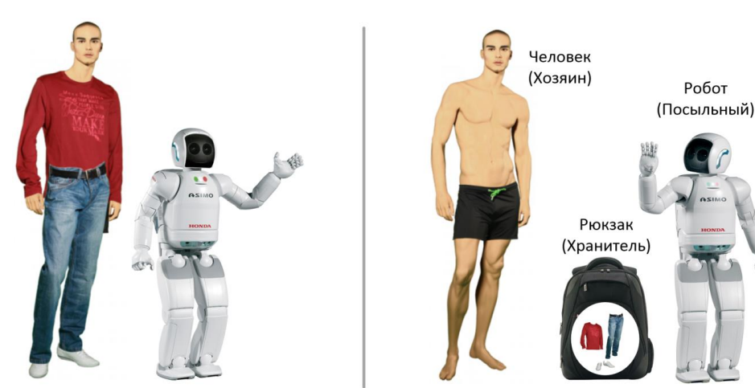

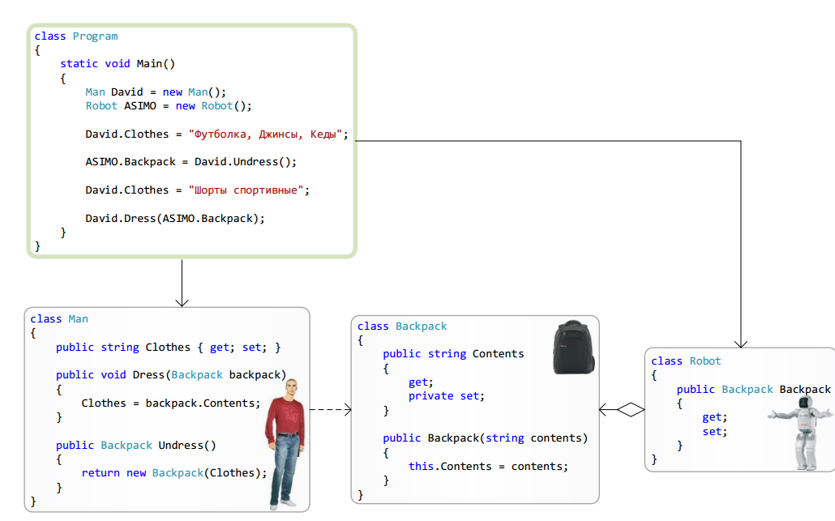

#### UML

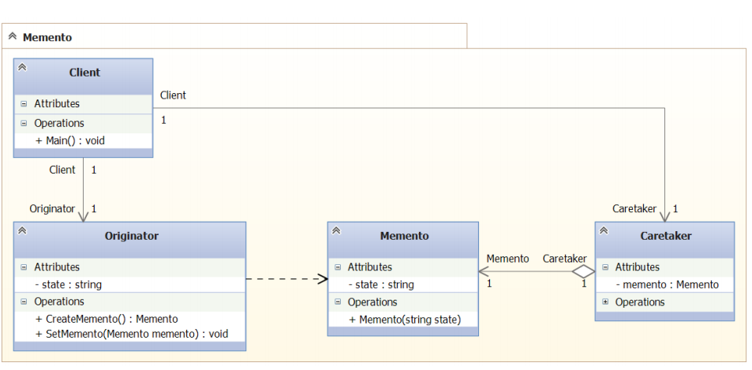

#### C#

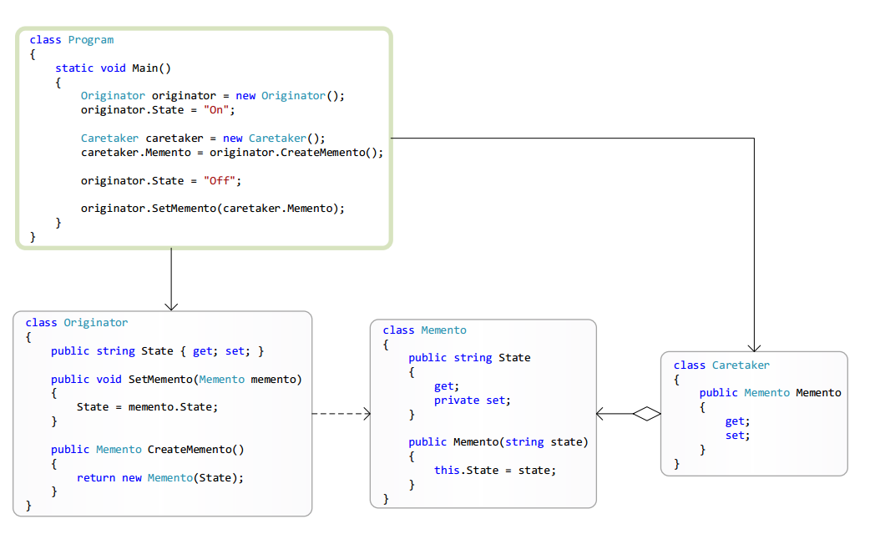

#### Usage

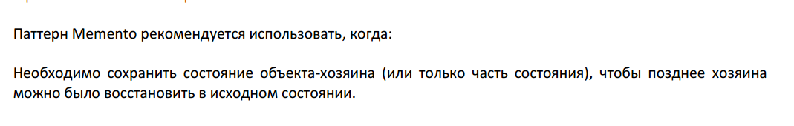

### Observer

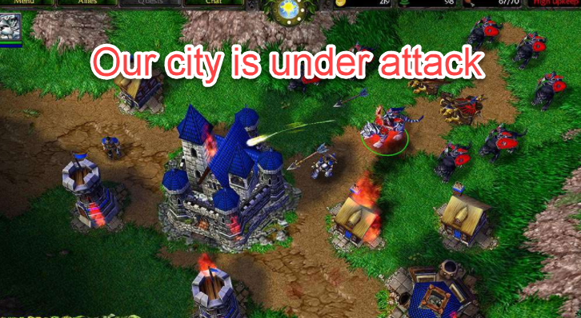

Popularity 5

#### UML

##### Pull

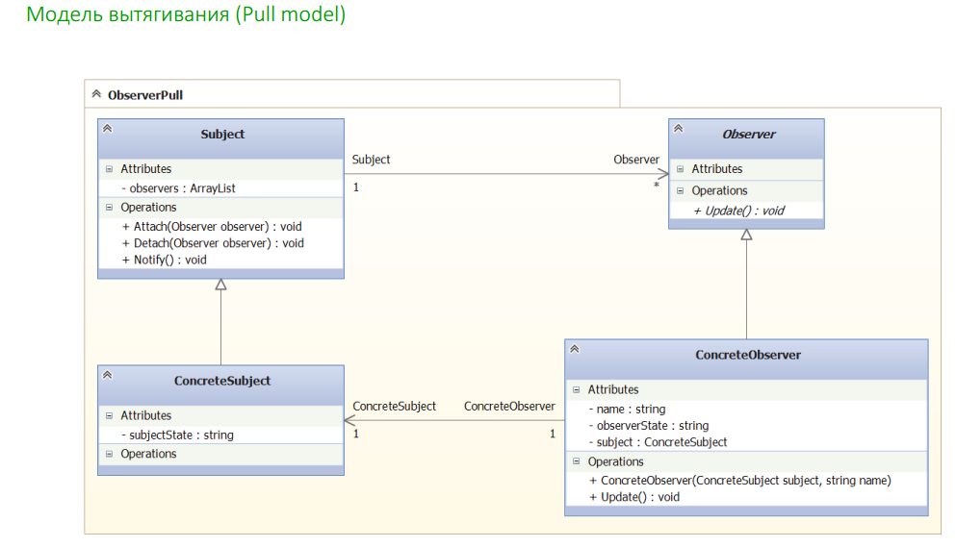

##### Push

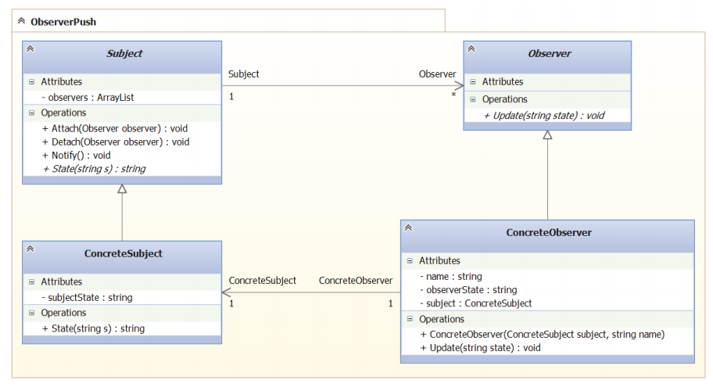

#### C#

##### Pull

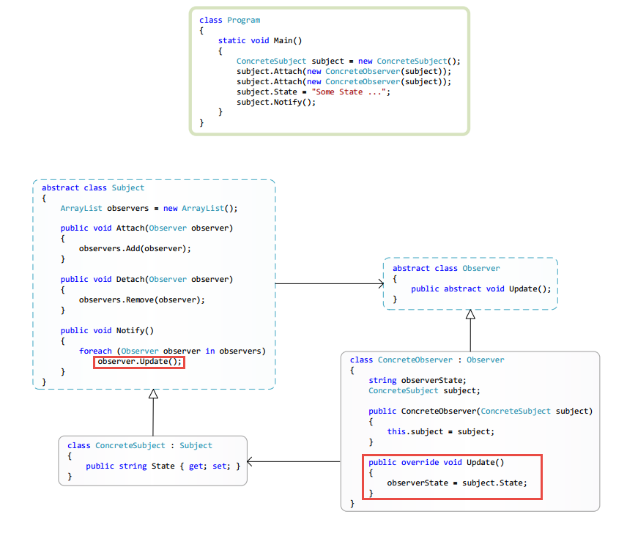

##### Push

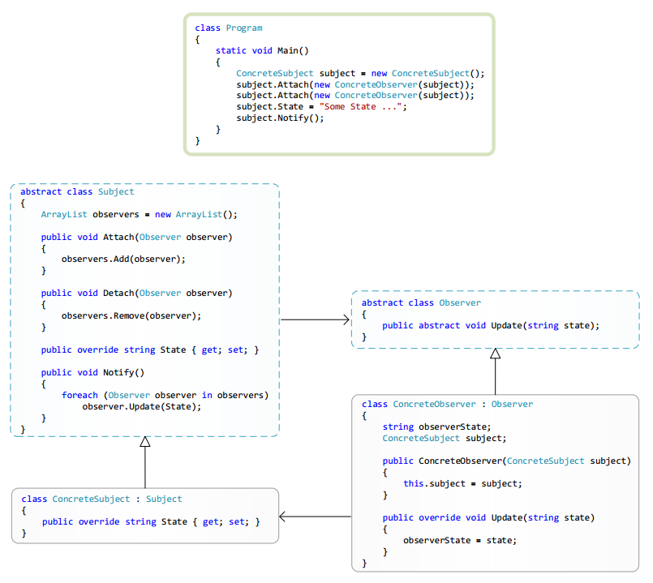

#### Motivation

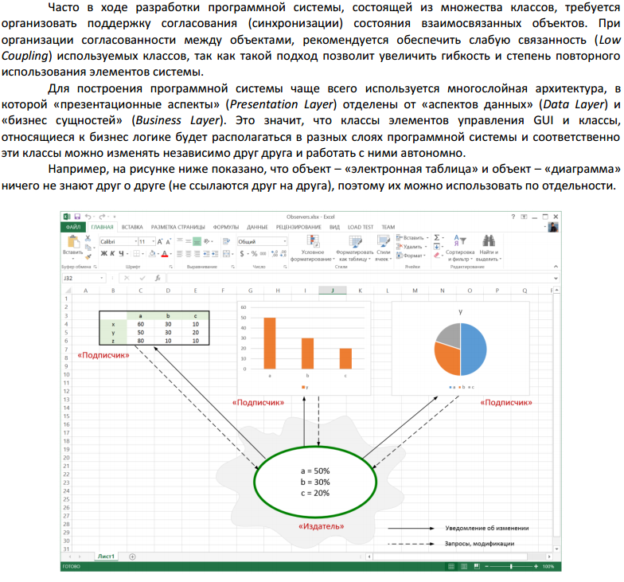

#### .NET Realization

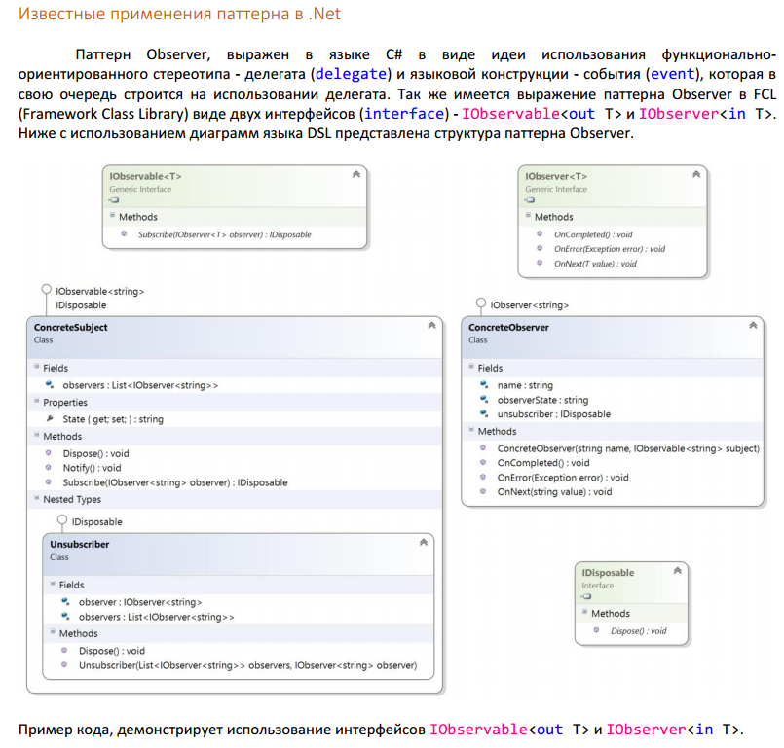

### State machine

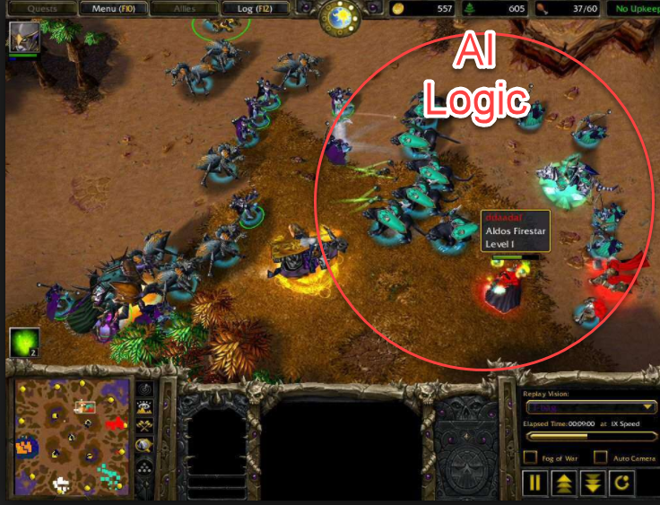

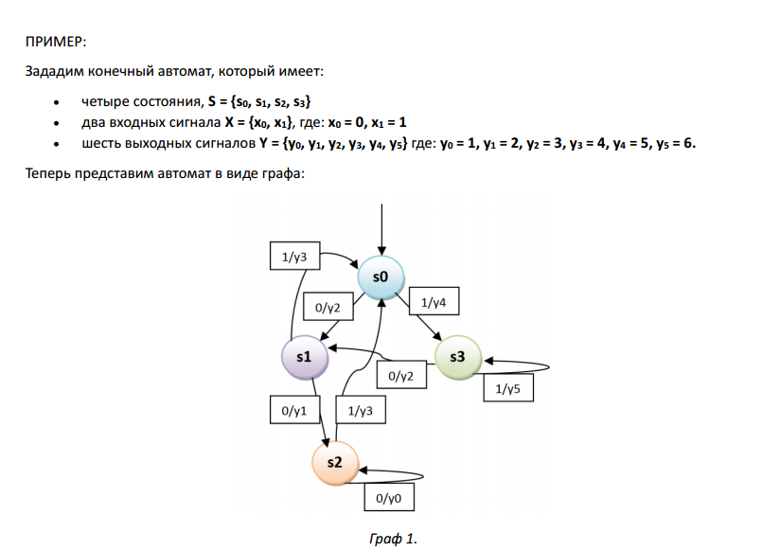

#### Мили(WWF)

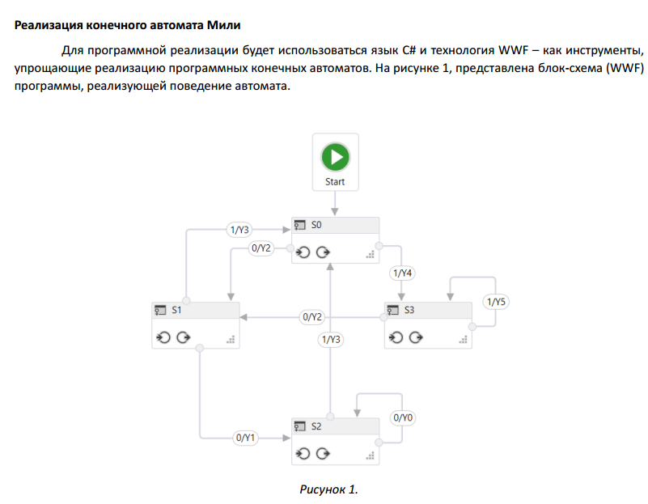

#### UML

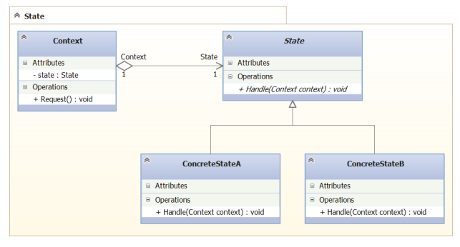

#### C#

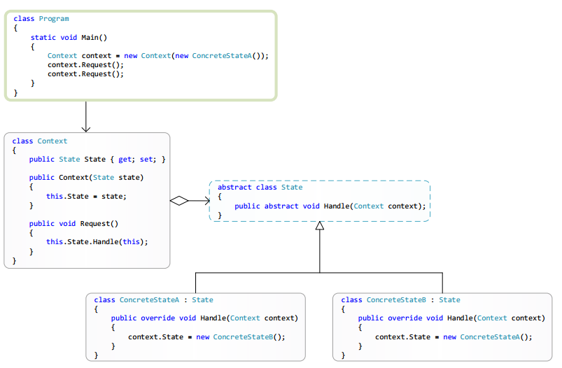

#### Example

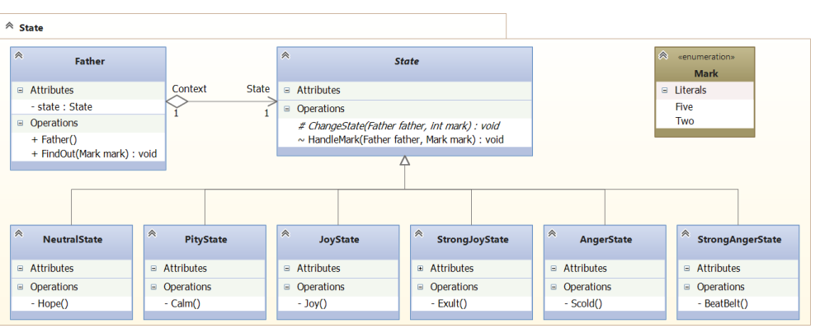

### Strategy

Allow us change the logic of program at runtime



Chnaging from random spawning to the script spawning then to the mix of random and script spawning. And types of enemys that will spawn.

Popularity 5

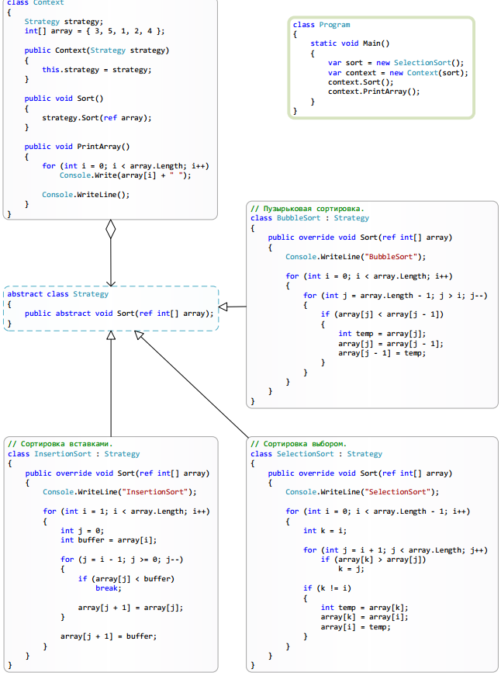

#### UML

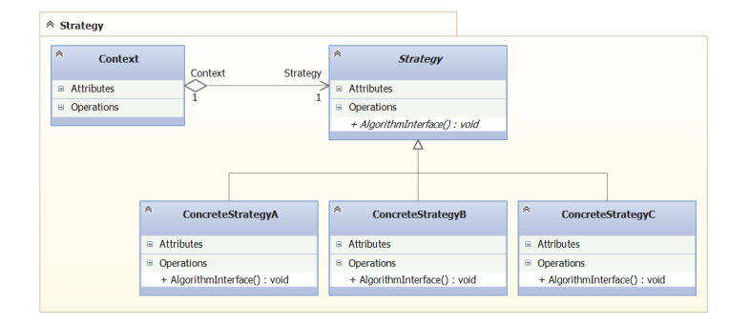

#### C#

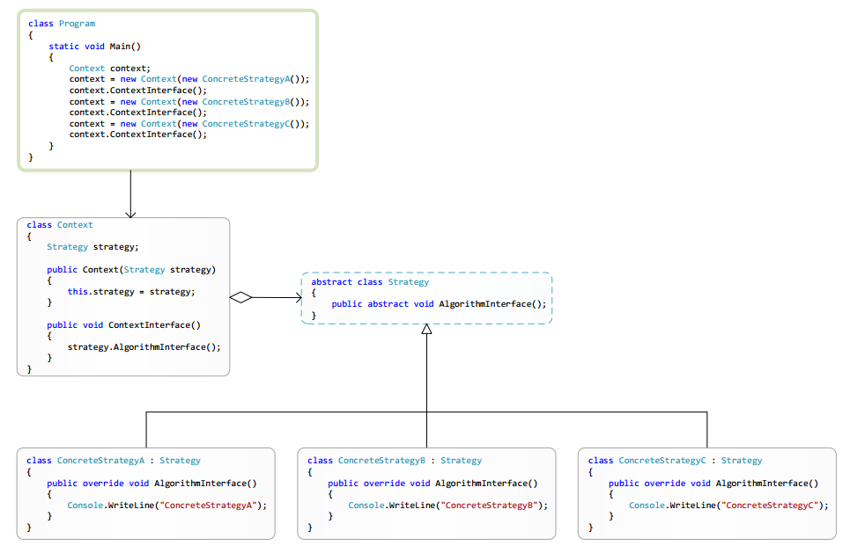

### Template Method

Imagin it as basic abstact type of unit. We know what unity will do. But dosen’t now how exactly.

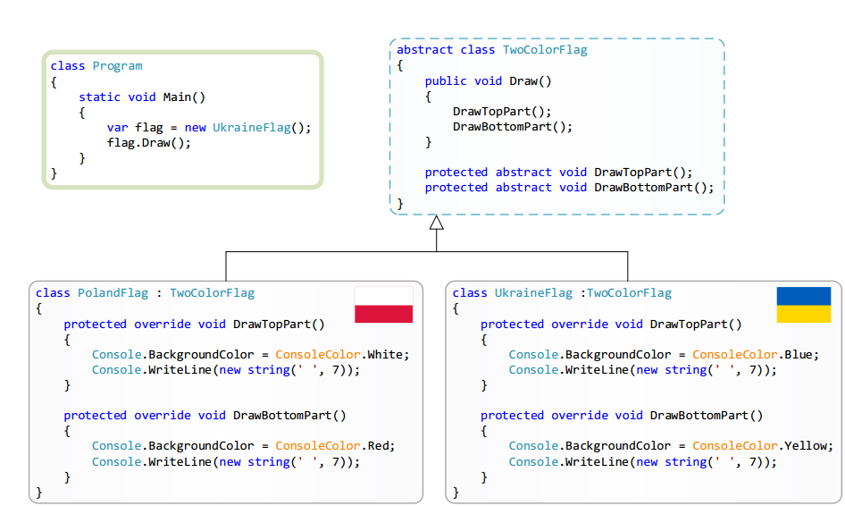

#### UML

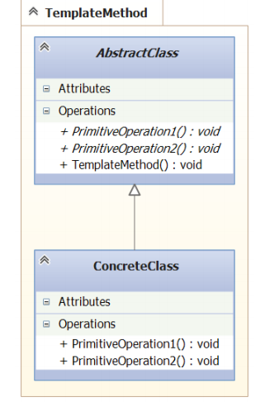

#### C#

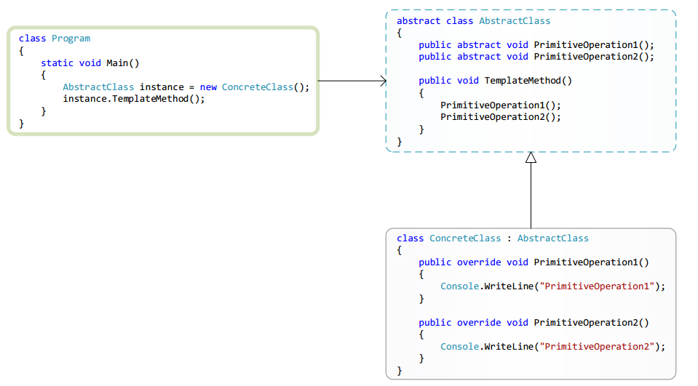

### Visitor

Паттерн Visitor – позволяет единообразно обойти набор элементов с разнородными интерфейсами

(т.е. набор объектов разных классов не приводя их к общему базовому типу), а также позволяет добавить

новый метод (функцию) в класс объекта, при этом не изменяя сам класс этого объекта

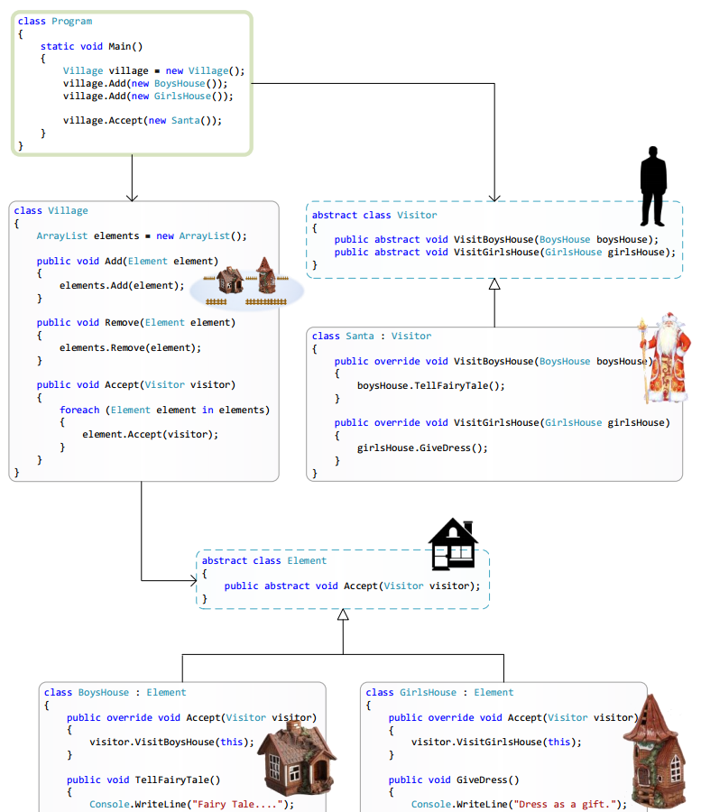

#### UML

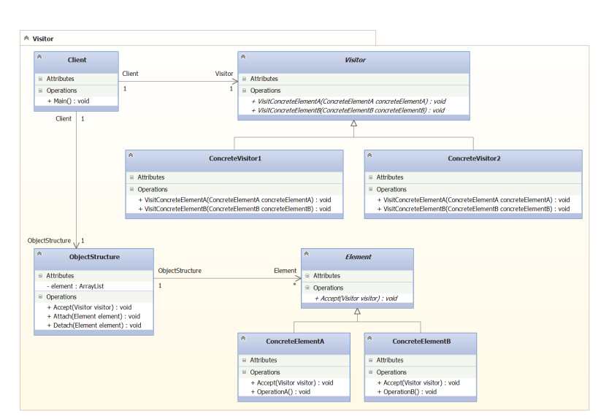

#### C#

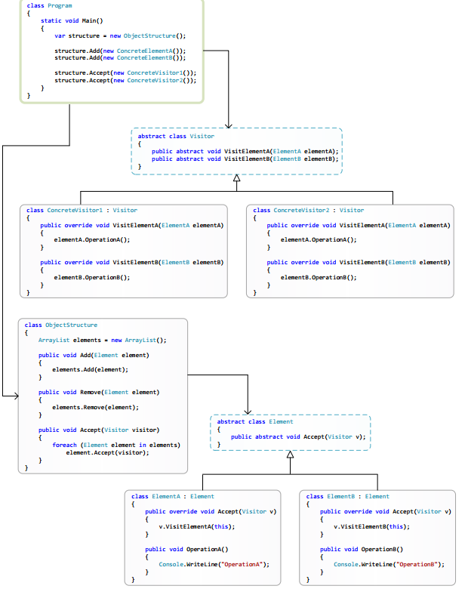

# Architectural patterns

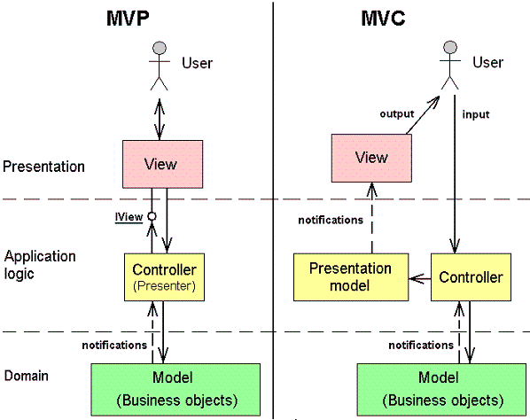

## Dependency Injection DI/IoC Inversion of Control

It’s basicly including the interfact in our architecture.

Dependency Injection simplifies the modular testin

There are three types of Dependency Injection

1. Constructor Injection
2. Setter Injection
3. Method Injection

### Ninject

<https://github.com/ninject/Ninject/wiki>

Ninject – the whole freamwork for c# for Dependency injection .

### Unity Dependency Injection

<http://www.what-could-possibly-go-wrong.com/dependency-injection-for-unity-part-1/?utm_source=ash&utm_medium=ash-reddit-unity3d&utm_campaign=dependency-injection3>

Article in English

<https://habr.com/ru/post/188438/>

Habr article on this topic

## Model-View-Controller

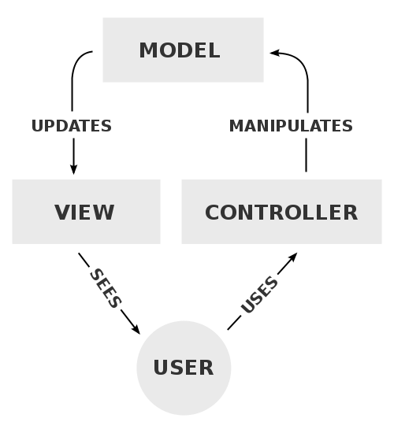

**Model–view–controller** (**MVC**) is a software [architectural pattern](https://en.wikipedia.org/wiki/Architectural_pattern) mostly (but not exclusively) for implementing [user interfaces](https://en.wikipedia.org/wiki/User_interface). It divides a given software application into three interconnected parts, so as to separate internal representations of information from the ways that information is presented to or accepted from the user.[[1]](https://en.wikipedia.org/wiki/Model%E2%80%93view%E2%80%93controller#cite_note-1)[[2]](https://en.wikipedia.org/wiki/Model%E2%80%93view%E2%80%93controller#cite_note-2)

### Interactions

In addition to dividing the application into three kinds of components, the model–view–controller design defines the interactions between them.[[13]](https://en.wikipedia.org/wiki/Model%E2%80%93view%E2%80%93controller#cite_note-posa-13)

* A **controller** can send commands to the model to update the model's state (e.g., editing a document). It can also send commands to its associated view to change the view's presentation of the model (e.g., by scrolling through a document).
* A **model** stores data that is retrieved according to commands from the controller and displayed in the view.
* A **view** generates an output presentation to the user based on changes in the model.
* A **view controller** generates an output view and an embedded controller

## Model-View-Presenter

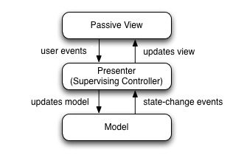

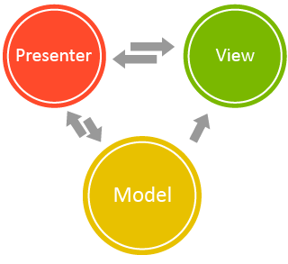

**Model–view–presenter** (**MVP**) is a derivation of the [model–view–controller](https://en.wikipedia.org/wiki/Model%E2%80%93view%E2%80%93controller) (MVC) [architectural pattern](https://en.wikipedia.org/wiki/Architectural_pattern), and is used mostly for building[user interfaces](https://en.wikipedia.org/wiki/User_interface).

In MVP the *presenter* assumes the functionality of the "middle-man". In MVP, all presentation logic is pushed to the presenter.[[1]](https://en.wikipedia.org/wiki/Model%E2%80%93view%E2%80%93presenter#cite_note-1)

MVP is a user interface [architectural pattern](https://en.wikipedia.org/wiki/Architectural_pattern_(computer_science)) engineered to facilitate automated unit testing and improve the [separation of concerns](https://en.wikipedia.org/wiki/Separation_of_concerns) in presentation logic:

* The *model* is an interface defining the data to be displayed or otherwise acted upon in the user interface.
* The *presenter* acts upon the model and the view. It retrieves data from repositories (the model), and formats it for display in the view.
* The *view* is a passive interface that displays data (the model) and routes user commands ([events](https://en.wikipedia.org/wiki/Event_(computing))) to the presenter to act upon that data.

Normally, the view implementation instantiates the concrete presenter object, providing a reference to itself. The following C# code demonstrates a simple view constructor, where ConcreteDomainPresenter implements the IDomainPresenter interface:

## Hierarchical Model-View-Controller

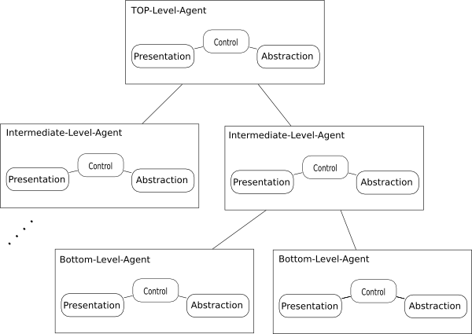

**Hierarchical model–view–controller (HMVC)** is a software [architectural pattern](https://en.wikipedia.org/wiki/Architectural_pattern), a variation of [model–view–controller](https://en.wikipedia.org/wiki/Model%E2%80%93view%E2%80%93controller) (MVC) similar to [presentation–abstraction–control](https://en.wikipedia.org/wiki/Presentation%E2%80%93abstraction%E2%80%93control) (PAC), that was published in 2000 in an article[[1]](https://en.wikipedia.org/wiki/Hierarchical_model%E2%80%93view%E2%80%93controller#cite_note-1)in [JavaWorld](https://en.wikipedia.org/wiki/JavaWorld" \o "JavaWorld) Magazine, the authors apparently unaware[[2]](https://en.wikipedia.org/wiki/Hierarchical_model%E2%80%93view%E2%80%93controller#cite_note-2) of PAC which was published 13 years earlier.

Ent

# **Managed Extensibility Framework(MEF)**

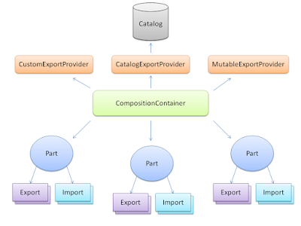

## Resources

[Article on Microsoft](https://docs.microsoft.com/en-us/dotnet/framework/mef/)

[Article on Habr](https://habr.com/post/83928/)

[Page on codePlex](https://archive.codeplex.com/?p=mef\)

It allows you to extend your application on runtime.

Something like Dicorator.

IN net it is based

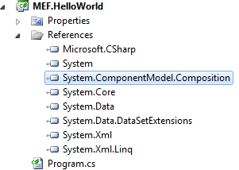

It works based on [Import] and [Export] attribute

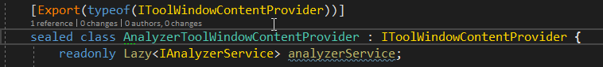

[Import]

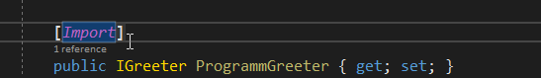

[ImportMany]

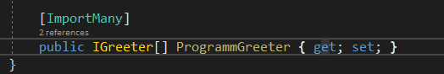

Export – shows opportunities that we can use

Import – Showes depnedencys that we have.

ImportMany – In case if you need a lot.

## Compose

So in order to use our opportunities we need to compose them.

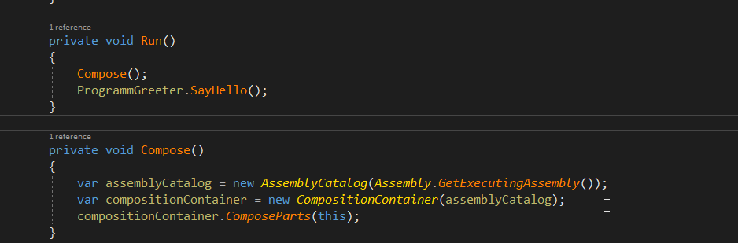

# Entitiy Component Systme



It has 3 parts to it Entity, Component and System

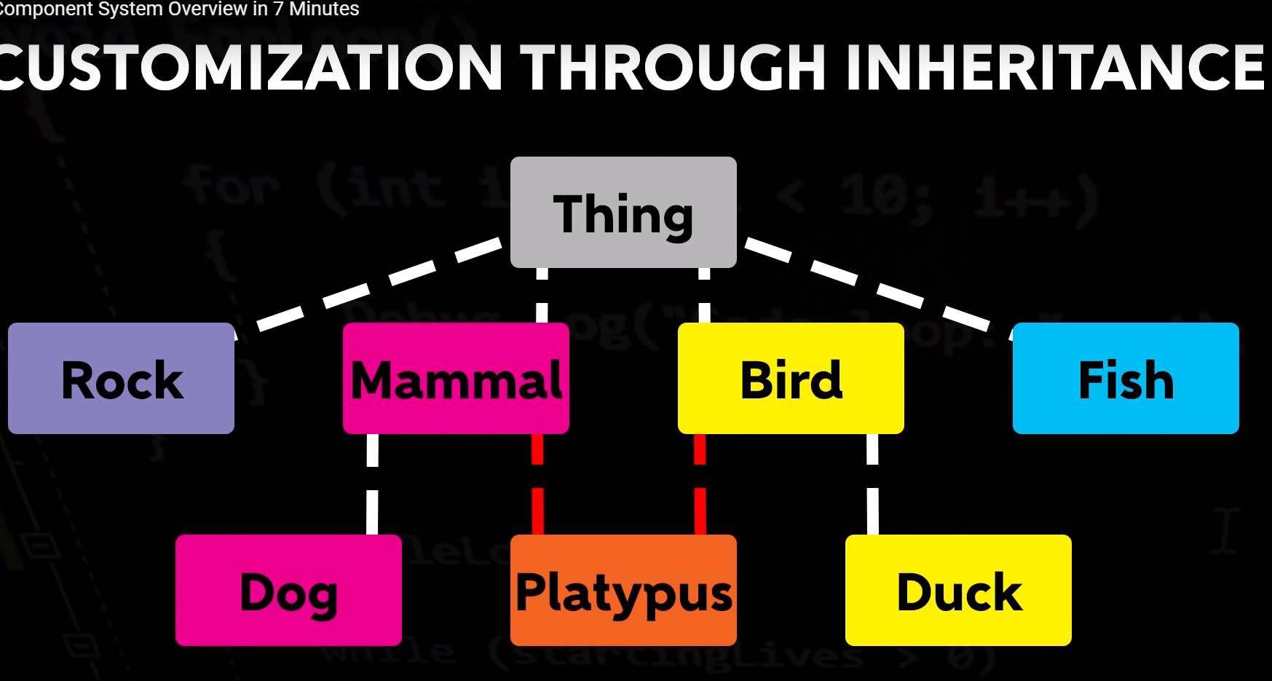

It’s basicly something

<https://unity3d.com/ru/learn/tutorials/topics/scripting/introduction-entity-component-system-and-c-job-system>

Unity tutorial



Entity Component system is banded with Enity component system.

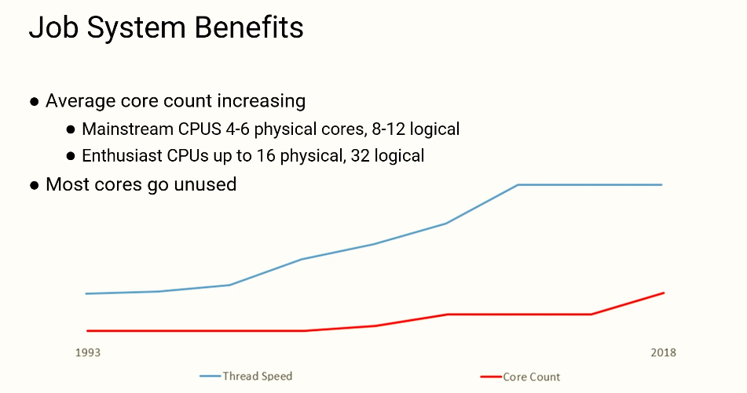

The thing is we have a lot of course but we utilize only two of them.

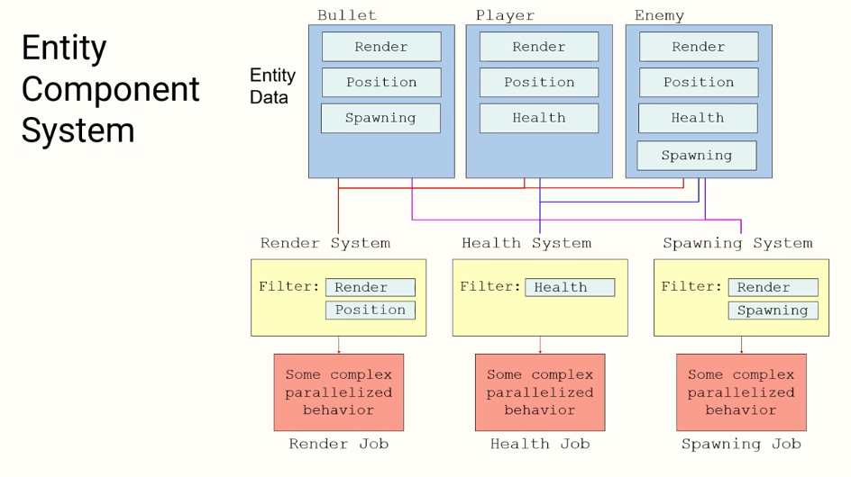It works more on systems itself more than on them all of them combined together.

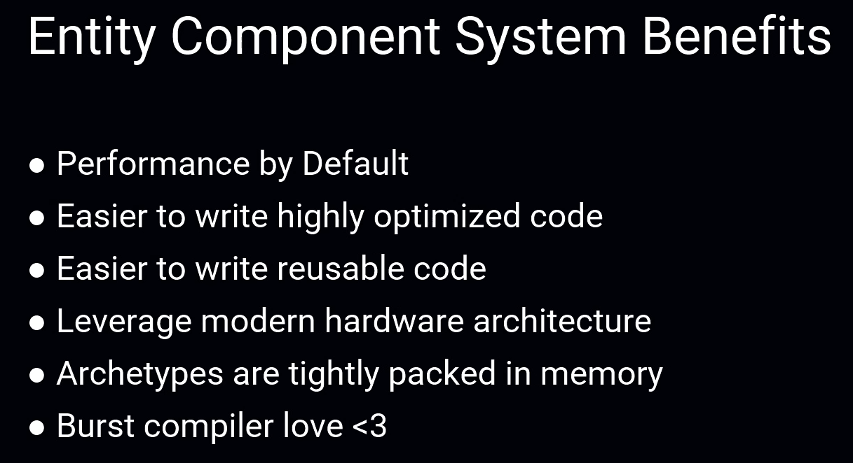

To reference the Transform for moving we are using

TransformAccess.

We Jump from 17,000 unity running forward into 96,000

With Burst compiler 156,000 CPU